

Skin Cancer Detection using Deep Learning

***Minor Project Report submitted in***

***partial fulfillment of requirement for the award of degree of***

# Bachelor of Technology in

**Artificial Intelligence**

***By***

# Mr. Shreyas Deogade Mr. Sarthak Udapure Ms. Himani Bhayde

***Guide***

# Prof. Ashwini Kukade

Assistant Professor Department of Artificial Intelligence G H Raisoni College of Engineering

# October 2024

**Department of Artificial Intelligence G H Raisoni College of Engineering**

An Empowered Autonomous Institute affiliated to Rashtrasant Tukadoji Maharaj Nagpur University, Nagpur Accredited by NAAC with “A++” Grade (3rd Cycle)

CRPF Gate No. 3, Hingna Road, Digdoh Hills, Nagpur – 440 016 (INDIA)

T: +91 9604787184, 9689903286, 9921008391 | E: [principal.ghrce@raisoni.net](mailto:principal.ghrce@raisoni.net) |W: ghrce.raisoni.net



# Declaration

We, hereby declare that the minor project report titled “**Skin Cancer Detection using Deep Learning** ” submitted herein has been carried out by us towards partial fulfillment of requirement for the award of Degree of Bachelor of Technology Artificial Intelligence. The work is original and has not been submitted earlier as a whole or in part for the award of any degree / diploma at this or any other Institution

/ University.

We also hereby assign to G H Raisoni College of Engineering, Nagpur all rights under copyright that may exist in and to the above work and any revised or expanded derivative work based on the work as mentioned. Other work copied from references, manuals etc. are disclaimed.

|  |  |  |  |
| --- | --- | --- | --- |
| **Name of student** | **Mobile No** | **Mail ID**  **(Other than Raisoni.net)** | **Signature** |
| Mr. Shreyas Deogade | 7499710788 | [shreyasdeogade123@gmail.com](mailto:shreyasdeogade123@gmail.com) |  |
| Mr. Sarthak Udapure | 7709316844 | [sarthak.udapure24@gmail.com](mailto:sarthak.udapure24@gmail.com) |  |
| Ms.Himani Bhayde | 8080533788 | [himanibhayde10@gmail.com](mailto:himanibhayde10@gmail.com) |  |

## Date:

**Place: Nagpur**

**Department of Artificial Intelligence G H Raisoni College of Engineering**

An Empowered Autonomous Institute affiliated to Rashtrasant Tukadoji Maharaj Nagpur University, Nagpur Accredited by NAAC with “A++” Grade (3rd Cycle)

CRPF Gate No. 3, Hingna Road, Digdoh Hills, Nagpur – 440 016 (INDIA)

T: +91 9604787184, 9689903286, 9921008391 | E: [principal.ghrce@raisoni.net](mailto:principal.ghrce@raisoni.net) |W: ghrce.raisoni.net

# Certificate

The minor project report entitled as “**Skin Cancer Detection using Deep Learning”** submitted by **Mr. Shreyas Deogade, Mr. Sarthak Udapure, Ms. Himani Bhayde** for the award of Degree of Bachelor of Technology in Artificial Intelligence has been carried out under my supervision. The work is comprehensive, complete and fit for evaluation.

## Prof. Ashwini Kukade Guide

**Assistant Professor**

Department of Artificial Intelligence G H R C E, Nagpur

## Dr. Mangala Madankar Head

Department of Artificial Intelligence G H R C E, Nagpur







# ACKNOWLEDGEMENT

I would like to express my profound gratitude to my guide Prof. Ashwini Kukade for her invaluable guidance. I also extend my thanks to our HOD Dr. Mangala Madankar and our Director Dr. Sachin Untawale for creating an excellent academic environment.

Finally, I acknowledge the teaching and non-teaching staff of the Department of Artificial Intelligence for the direct or indirect help given to me in completing this project and for providing consistent encouragement.

I would like to acknowledge that this project was completed entirely by Mr. Shreyas Deogade, Mr. Sarthak Udapure and Ms. Himani Bhayde With a deep sense of gratitude.

Projectee Projectee

Shreyas Deogade Sarthak Udapure

Signature Signature

Projectee Himani Bhayde

Signature

# ABSTRACT

One of the most serious types of cancer is skin cancer. The rising number of skin cancer cases, high mortality rate, and high cost of medical treatment necessitate early detection of its symptoms. Skin cancer is detected and differentiated from melanoma using lesion criteria such as symmetry, color, size, and shape. Given the significance of these challenges, researchers have developed a variety of early-detection approaches for skin cancer. Skin cancer detection using deep learning (DL) has significantly advanced the field of medical imaging, offering promising solutions for early and accurate diagnosis. Skin cancer detection using deep learning (DL) represents a transformative advancement in dermatology, offering enhanced accuracy and efficiency in early diagnosis.

# List of Figures

|  |  |  |
| --- | --- | --- |
| **Sr.No.** | **Figures** | **Figures Name** |
| 1. | 1 | Flowchart |
| 2. | 1,2 | Output |

**List of Table**

|  |  |  |
| --- | --- | --- |
| **Sr.No.** | **Table Number** | **Table Name** |
| 1 | 1 | Literature Survey Table |

**INDEX**

|  |  |  |
| --- | --- | --- |
| **Sr. No.** | **Topics** | **Page. No.** |
| **1.** | **ABSTRACT** | **iv** |
| **2.** | **INTRODUCTION** | **1** |
| **3.** | **LITERATURE SURVEY TABLE** | **2** |
| **4.** | **OBJECTIVES** | **9** |
| **5.** | **PROPOSED METHODOLOGY** | **10** |
| **6.** | **FLOWCHART** | **11** |
| **7.** | **WORKING METHODOLOGY** | **12** |
| **8.** | **IMLPEMENTATION** | **14** |
| **9.** | **OUTPUT** | **23** |
| **10.** | **SOFTWARE SPECIFICATIONS** | **25** |
| **11.** | **FUTURE SCOPE** | **26** |
| **12.** | **CONCLUSION** | **27** |
| **13.** | **REFERENCES** | **28** |

**INTRODUCTION**

Skin cancer is a leading cause of cancer-related deaths worldwide, largely due to its increasing incidence and the challenges associated with early diagnosis. Early detection of skin cancer significantly enhances the effectiveness of treatment and improves patient outcomes. However, traditional diagnostic methods, including visual examinations and dermoscopic assessments, are often limited by the subjective nature of human evaluation and variability in expertise among practitioners.

In recent years, deep learning has emerged as a transformative technology in medical imaging, offering the potential to revolutionize diagnostic accuracy and consistency. By harnessing the power of Convolutional Neural Networks (CNNs) and other advanced deep learning techniques, this project aims to develop a robust and automated system for skin cancer detection. The proposed system utilizes large-scale, annotated dermatological image datasets to train models capable of accurately classifying skin lesions as benign or malignant.

This approach seeks to address the limitations of conventional methods by providing a reliable, objective tool to assist dermatologists in making more precise and timely diagnoses, ultimately improving patient care and streamlining healthcare practices.

# LITERATURE SURVEY TABLE

|  |  |  |  |  |
| --- | --- | --- | --- | --- |
| **Sr. No** | **Title of the Article Author Year of**  **publication** | **Objective and method used** | **Conclusion and result** | **Future Scope** |
| 1 | Skin Cancer | This study | the classification | Key issues |
|  | Detection | aimed to | accuracies of four | include the |
|  | Based on | propose viable | approaches on the binary | need for large, |
|  | Deep | deep learning | and 8-class tasks, | high-quality |
|  | Learning | (DL) based | including malignant | datasets to |
|  | Reza | method for the | melanoma, benign | avoid |
|  | Ahmadi | detection of | melanocytic nevus, | overfitting and |
|  | Mehr1 , Ali | skin cancer in | malignant and pre- | ensure |
|  | Ameri2 | lesion images, | malignant KC, benign | generalization. |
|  | 2022 | to help | keratosis, malignant | These models |
|  |  | physicians in | cutaneous lymphoma, | can also suffer |
|  |  | diagnosis. In | benign eczema and | from limited |
|  |  | this | dermatitis, malignant | interpretability, |
|  |  | analytical | dermal lesions, and | making it hard |
|  |  | study, a | benign dermal lesions. | for physicians |
|  |  | novel DL based |  | to understand |
|  |  | model was |  | their decision- |
|  |  | proposed. |  | making |
|  |  |  |  | processes. |

|  |  |  |  |  |
| --- | --- | --- | --- | --- |
| 2 | Skin Cancer | Considering | This systematic review | Future research |
|  | Detection: | the | paper has discussed | can include |
|  | A | seriousness of | various neural network | full-body |
|  | Review | these | techniques for skin | photography to |
|  | Using | issues, | cancer detection and | seek the |
|  | Deep | researchers | classification. All of | answer to the |
|  | Learning | have | these techniques are | question that |
|  | Techniques | developed | noninvasive. Skin cancer | typically arises. |
|  | Mehwish | various early | detection requires | Autonomous |
|  | Dildar 1 , | detection | multiple stages, such as | full-body |
|  | Shumaila | techniques for | preprocessing and image | photography |
|  | Akram 2 | skin cancer | segmentation, followed | will |
|  | , |  | by feature extraction and | automate and |
|  | Muhamma |  | classification. | speed up the |
|  | d Irfan |  |  | image |
|  | 3 , 2021 |  |  | acquisition |
|  |  |  |  | phase |
| 3 | A | Skin cancer is a | This paper has reviewed | One of the |
|  | comprehen | significant | the use of deep learning | most significant |
|  | sive | health risk that | techniques, specifically | challenges |
|  | study on | requires early | Artificial Neural | faced is that |
|  | skin | detection for | Network (ANN) and | the |
|  | cancer | effective | Convolutional Neural | neural |
|  | detection | treatment. This | Network (CNN), for the | network-based |
|  | using | paper | early detection of skin | skin |
|  | artificial | discusses two | cancer. Through a | cancer |
|  | neural | automated | comprehensive | methods |
|  | network | techniques, | evaluation of various | require |
|  | (ANN) and | Artificial Neural | research studies, the | extensive |
|  | convolution | Network (ANN) | effectiveness and | training. The |
|  | al | and | performance of these | system must |
|  | neural | Convolutional | techniques in skin cancer | undergo |
|  | network | Neural | diagnosis have been | precise training |
|  | (CNN) | Network | established. | for accurate |
|  | Aarushi | (CNN), which |  | interpretation |
|  | Shah a , | make use of |  | and analysing. |
|  | Manan | deep learning |  | This is very |
|  | Shah  b,⇑,Aum | techniques for  skin cancer |  | time  consuming and |

|  |  |  |  |  |
| --- | --- | --- | --- | --- |
|  | Pandya c , Rajat Sushra d  2023 | detection. SVM, KNN |  | requires powerful and strong  hardware. |
| 4 | Skin cancer | To build deep | The deep learning models | The provision |
|  | detection: | learning | built here are | to download |
|  | Applying a | models to | tested on standard | the trained |
|  | deep | classify dermal | datasets, and the metric | model and |
|  | learning | cell images and | area under the curve of | develop |
|  | based | detect skin | 99.77% was observed. A | enterprise level |
|  | model | cancer. | practitioner can use the | applications is |
|  | driven | Methods: A | model-driven | the best seed |
|  | architectur | model- | architecture and quickly | level research |
|  | e in the | driven | build the deep learning | that this paper |
|  | cloud for | architecture in | models to predict skin | observes for |
|  | classifying | the cloud, that | cancer. | the future |
|  | dermal cell | uses deep |  | work. Finally, |
|  | images | learning |  | the paper |
|  | Mohamma | algorithms in |  | achieved the |
|  | d Ali | its core |  | set objectives |
|  | Kadampur | implementatio |  | of the |
|  | * , | ns, is |  | introductory |
|  | Sulaiman Al | used to |  | section. |
|  | Riyaee | construct |  |  |
|  | 2020 | models that |  |  |
|  |  | assist in |  |  |
|  |  | predicting skin |  |  |
|  |  | cancer with |  |  |
|  |  | improved |  |  |
|  |  | accuracy. |  |  |
| 5 | Skin cancer | This project is | Globally, there is a drastic | The authors |
|  | detection | about | increase in the rate of | declare that |
|  | and | detection and | skin cancer cases because | they have no |
|  | classificatio | classification of | of several factors. So | known |
|  | n using | various | early detection plays a | competing |
|  | machine | types of skin | crucial role in detection | financial |
|  | learning M. | cancer | and treatment. Thus, this | interests or |
|  | Krishna | using machine | paper discusses an | personal |
|  | Monika a , | learning | approach based on the | relationships |

|  |  |  |  |  |
| --- | --- | --- | --- | --- |
|  | N. Arun Vignesh 2020 | and image processing tools. In the pre-  processing stage, dermoscopic images  are considered  as input. | MSVM classification, where it uses two effective methods called ABCD and MSVM for feature extraction. The accuracy achieved is about 96.25%. | that could have appeared to  influence the work reported in this paper. |
| 6 | Deep Learning Solutions for Skin Cancer Detection and Diagnosis Hardik Nahata and Satya | The cardinal objective of this project is to develop state of the art Convolutional Neural Network (CNN) model to  perform the classification of skin lesion | It explored the data augmentation technique as a preprocessing step to strengthen the classification robustness of the CNN model. The best model, namely InceptionResnet achieved an average accuracy of 91%. | Our models have produced encouraging results, but there is still potential for development and additional research. |
|  | P. Sing  2020 | images into respective cancer types. The model is trained and tested on the  dataset made. |  |  |
| 7 | A precise | The proposed | A precise model for skin | In order to |
|  | model for | approach aims | cancer diagnosis using | reduce |
|  | skin cancer | to increase the | hybrid UNet and | computing |
|  | diagnosis | precision and | improved MobileNetV3 | complexity, |
|  | using | efcacy of skin | with hyperparameters | future studies |
|  | hybrid | cancer | optimization Umesh | should |
|  | UNet and | recognition | Kumar Lilhore1 , Sarita | concentrate on |
|  | improved | and | Simaiya1 , | improving the |
|  | MobileNet | consequently |  | model. To |

|  |  |  |  |  |
| --- | --- | --- | --- | --- |
|  | V3 with hyperpara meters optimizatio n  Umesh Kumar Lilhore1 , Sarita Simaiya1 , 2024 | enhance patients’ experiences. This investigation aims to tackle various signifcant challenges in skin cancer recognition, encompassing feature extraction, model architecture design, and optimizing hyperparamete  rs |  | improve the practicality of deployment, it may be  worthwhile to investigate model compression approaches or lightweight designs. Solving problems with interpretability might be crucial. |
| 8 | A Review of Skin  Cancer Detection: Traditional and  Deep Learning- Based Techniques Maha Ali Hussien1* , Abbas  H. Hassin Alasadi2 2023 | Skin cancer is detected and differentiated from melanoma using lesion criteria such as symmetry, color, size, and shape. | This research paper provides information about skin cancer, its danger, its various types, and its causes. Also, it explains that early diagnosis of this disease has an effective role in ruining the lives of many people with it, as well as the importance of building an electronic model to detect the disease easily using images of skin debridement for cancer. | These criteria can be  subjective, leading to  variability in diagnoses and potentially missing early stage melanomas.  Benign lesions may resemble malignant ones, complicating differentiation. |
| 9 | Automatic  Skin Cancer | Computational  methods can | Computational methods  for automated PSL | Computational  methods for |

|  |  |  |  |  |
| --- | --- | --- | --- | --- |
|  | Detection Using Clinical Images: A Comprehen sive Review Sana  Nazari and Rafael Garcia  2023 | be a valuable tool for  assisting dermatologists in identifying skin cancer. Most research in machine learning for skin cancer detection has focused on dermoscopy images  due to the  existence of larger image datasets. | detection can be of great help when assisting dermatologists in the early diagnosis of skin cancer and specifically among computational methods, machine learning has proven to be very effective to aid general practitioners to spot high-risk moles when standard, off-the- shelf cameras are used. | skin cancer detection using machine learning on dermoscopy images face several challenges.  These include potential overfitting to specific image types, dataset limitations that may not  represent all skin conditions, and biases due  to varied image quality. |
| 10 | Skin Cancer Detection using  Deep Learning  R. Senthil Kumar 2022 | Identifying melanoma at the early stages of  diagnosis is imperative as early detection can exponentially increase one’s chances of  cure. The  paper first proposes a literature survey of multiple | Our methodology  consists of using  Convolutional Neural Network (CNN) to identify and diagnose the skin cancer using the IS IC dataset containing 2637 images. The accuracy of 88% for classifying the training proposed model gives an dataset as either benign or malignant. | These include the potential for inconsistent results across different techniques, varying levels of accuracy in early detection, and the  challenge of integrating findings from multiple methods into a cohesive diagnostic |

|  |  |  |  |  |
| --- | --- | --- | --- | --- |
|  |  | methods used for performing skin cancer  classification. |  | strategy. |

**OBJECTIVES**

* To automate the evaluation of the system to offer a consistent and analysis through images.
* To predict the skin cancer with of the images using Deep learning techniques to achieve the higher accuracy.

# PROPOSED METHODOLOGY

* To develop a deep learning system for skin cancer detection, start by collecting a diverse set of labeled dermoscopic images and applying data augmentation to enhance dataset variability.
* Preprocess the images by resizing them to a uniform resolution, normalizing pixel values, and optionally segmenting lesions from the surrounding skin.
* Choose a suitable deep learning architecture, such as ResNet or Inception, and leverage transfer learning to speed up training and improve performance.
* Split the data into training, validation, and test sets, then train the model using appropriate loss functions and optimization techniques while tuning hyper parameters for optimal results.
* Evaluate the model's performance with metrics like accuracy, precision, recall, and AUC-ROC, and use cross-validation to ensure robustness.
* Deploy the model in a user-friendly application or web service, and continuously monitor and update it as needed.
* Address ethical considerations by ensuring data privacy and mitigating biases, and collaborate with healthcare professionals for clinical validation and ongoing refinement.



Start

Gather a comprehensive

dataset from sources including dermatology image

Prepare the collected data for

analysis like image resizing, normalization

Extract meaningful features

from images

Reduce the feature space while

retaining imp information

Model training and evaluation

No

Achieve highest

accuracy

Yes

Prediction done at higher accuracy

Continuous monitoring

End

# FLOWCHART

**WORKING METHODOLOGY**

## Data Collection

* **Source Identification**: Gather a comprehensive dataset from reputable sources like:
* Dermatology image repositories (e.g., ISIC Archive).
* Public datasets like HAM10000 or PH2.
* Clinical collaborations for real patient images.

## Data Preparation

* **Data Cleaning**: Remove duplicates, irrelevant images, or mislabeled data.
* **Image Resizing**: Standardize image dimensions (e.g., 224x224 pixels) to ensure uniformity across the dataset.
* **Normalization**: Scale pixel values to a range of [0, 1] or [-1, 1] to improve model convergence.

## Feature Extraction

* **Use of Pre-trained Models**: Utilize convolutional neural networks (CNNs) like VGG16, ResNet, or Inception for feature extraction. These models can be fine-tuned or used as feature extractors.
* **Transfer Learning**: Leverage pre-trained weights on ImageNet to reduce training time and enhance performance.

## Feature Reduction

* **Dimensionality Reduction Techniques**: Apply techniques like PCA (Principal Component Analysis) or t-SNE (t-distributed Stochastic Neighbor Embedding) to reduce feature space while retaining essential information.
* **Feature Selection**: Identify and retain features that contribute most to model performance using methods like Recursive Feature Elimination (RFE) or Lasso regularization.

## Model Training

* **Model Selection**: Choose appropriate architectures (e.g., CNN, DenseNet, EfficientNet) based on problem complexity and available data.

## Training Process:

* Split data into training, validation, and test sets (e.g., 70% training, 15% validation, 15% test).
* Use data augmentation techniques (e.g., rotation, flipping) to increase training set diversity.

## Model Evaluation

* **Metrics**: Use accuracy, precision, recall, F1 score, and AUC-ROC as performance metrics to evaluate model effectiveness.
* **Cross-Validation**: Implement k-fold cross-validation to ensure model generalization across different data splits.

## Achieving High Accuracy

* **Hyperparameter Tuning**: Use grid search or random search to find optimal hyperparameters (e.g., learning rate, batch size).
* **Ensemble Learning**: Combine predictions from multiple models to improve accuracy and robustness.

## Prediction

* **Inference**: Use the trained model to make predictions on new images.
* **Thresholding**: Set a decision threshold for classification, balancing sensitivity and specificity.

## Continuous Monitoring

* **Model Drift Detection**: Implement monitoring to detect any shifts in data distribution over time.
* **Regular Retraining**: Schedule periodic retraining of the model with new data to maintain accuracy.
* **Feedback Loop**: Collect feedback from predictions and outcomes to improve the model iteratively.

## Documentation and Reporting

* **Results Analysis**: Document model performance and any insights gained during training and evaluation.
* **User Interface**: If applicable, develop a user-friendly interface for clinicians to input images and receive predictions.

## Deployment

* **Model Deployment**: Deploy the model in a clinical setting or through a web application, ensuring proper integration and user accessibility.
* **User Training**: Provide training sessions for users to ensure they understand how to use the model effectively.

# IMPLEMENTATION

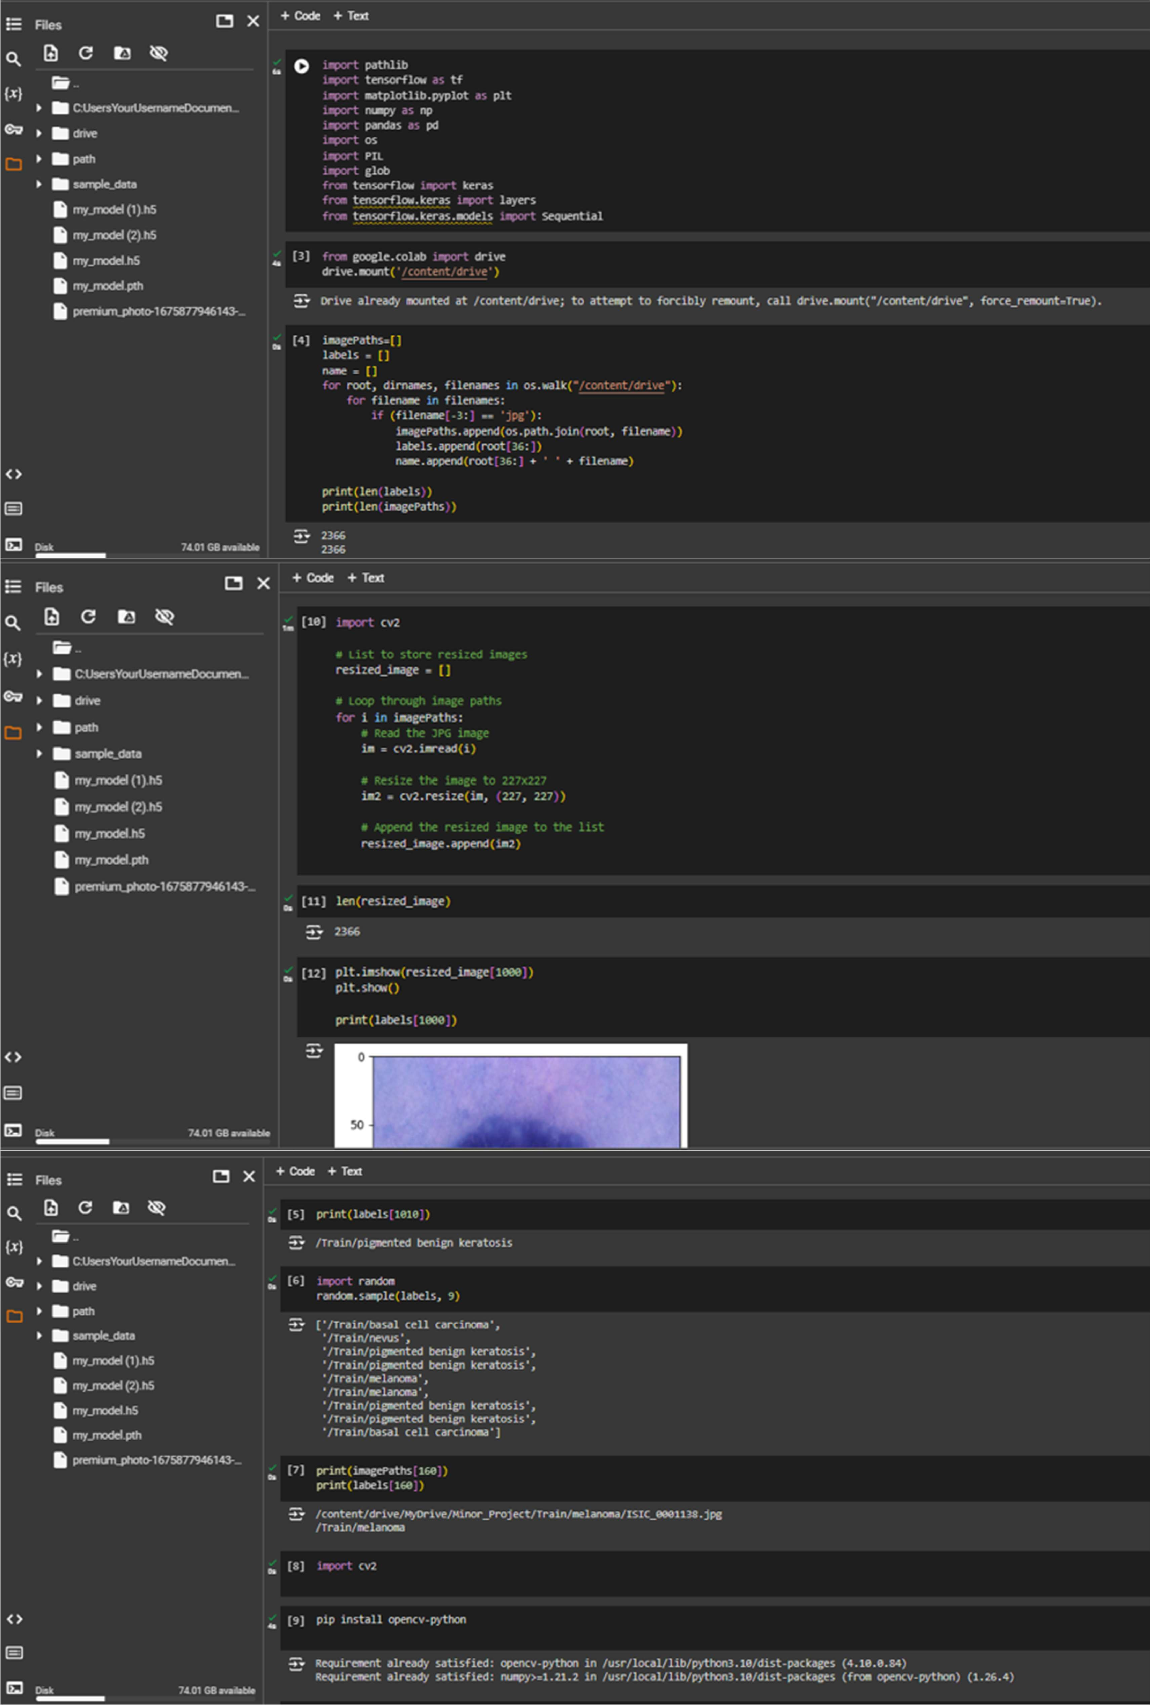

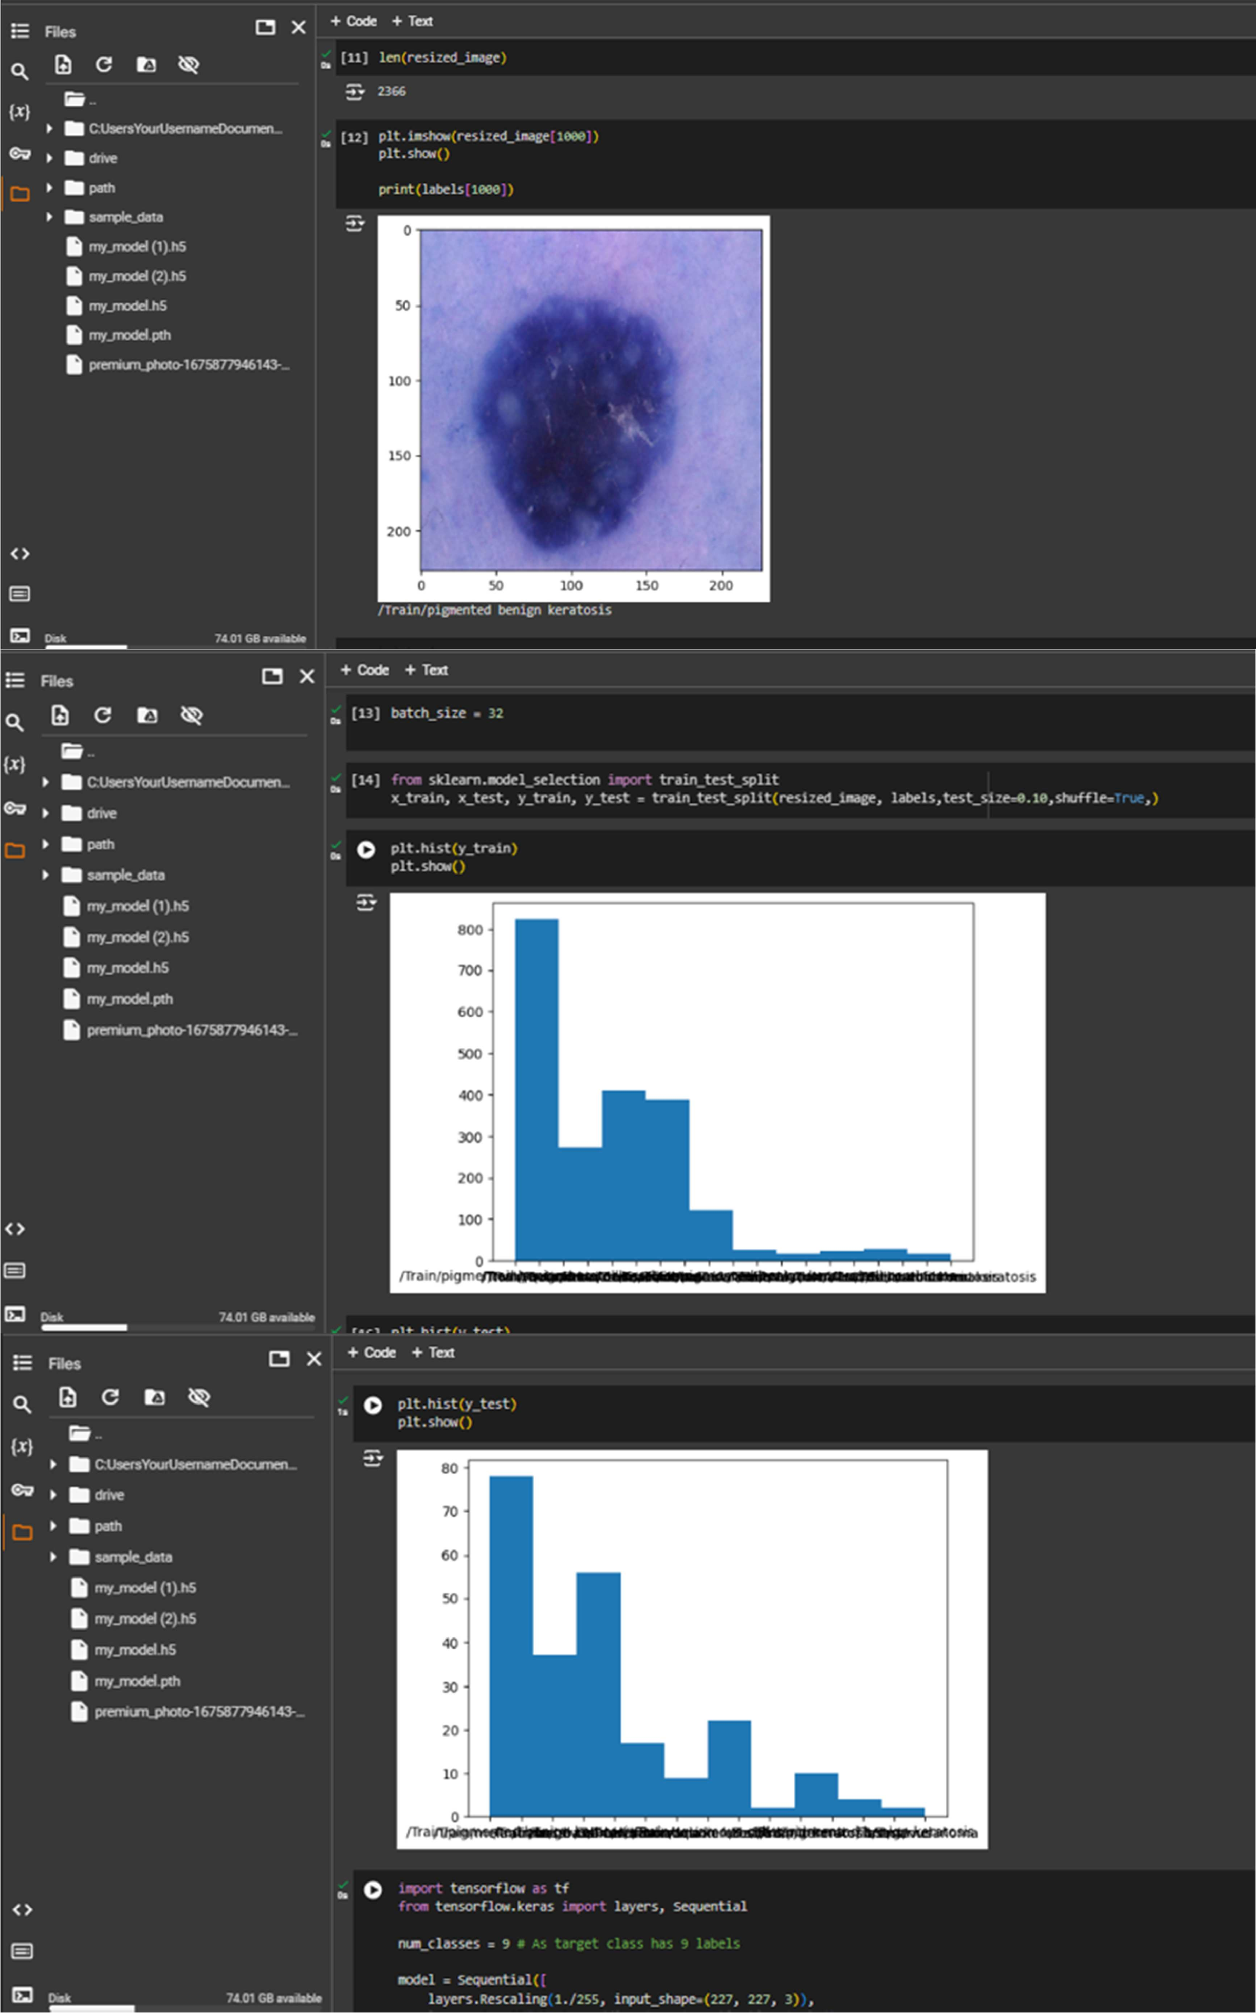

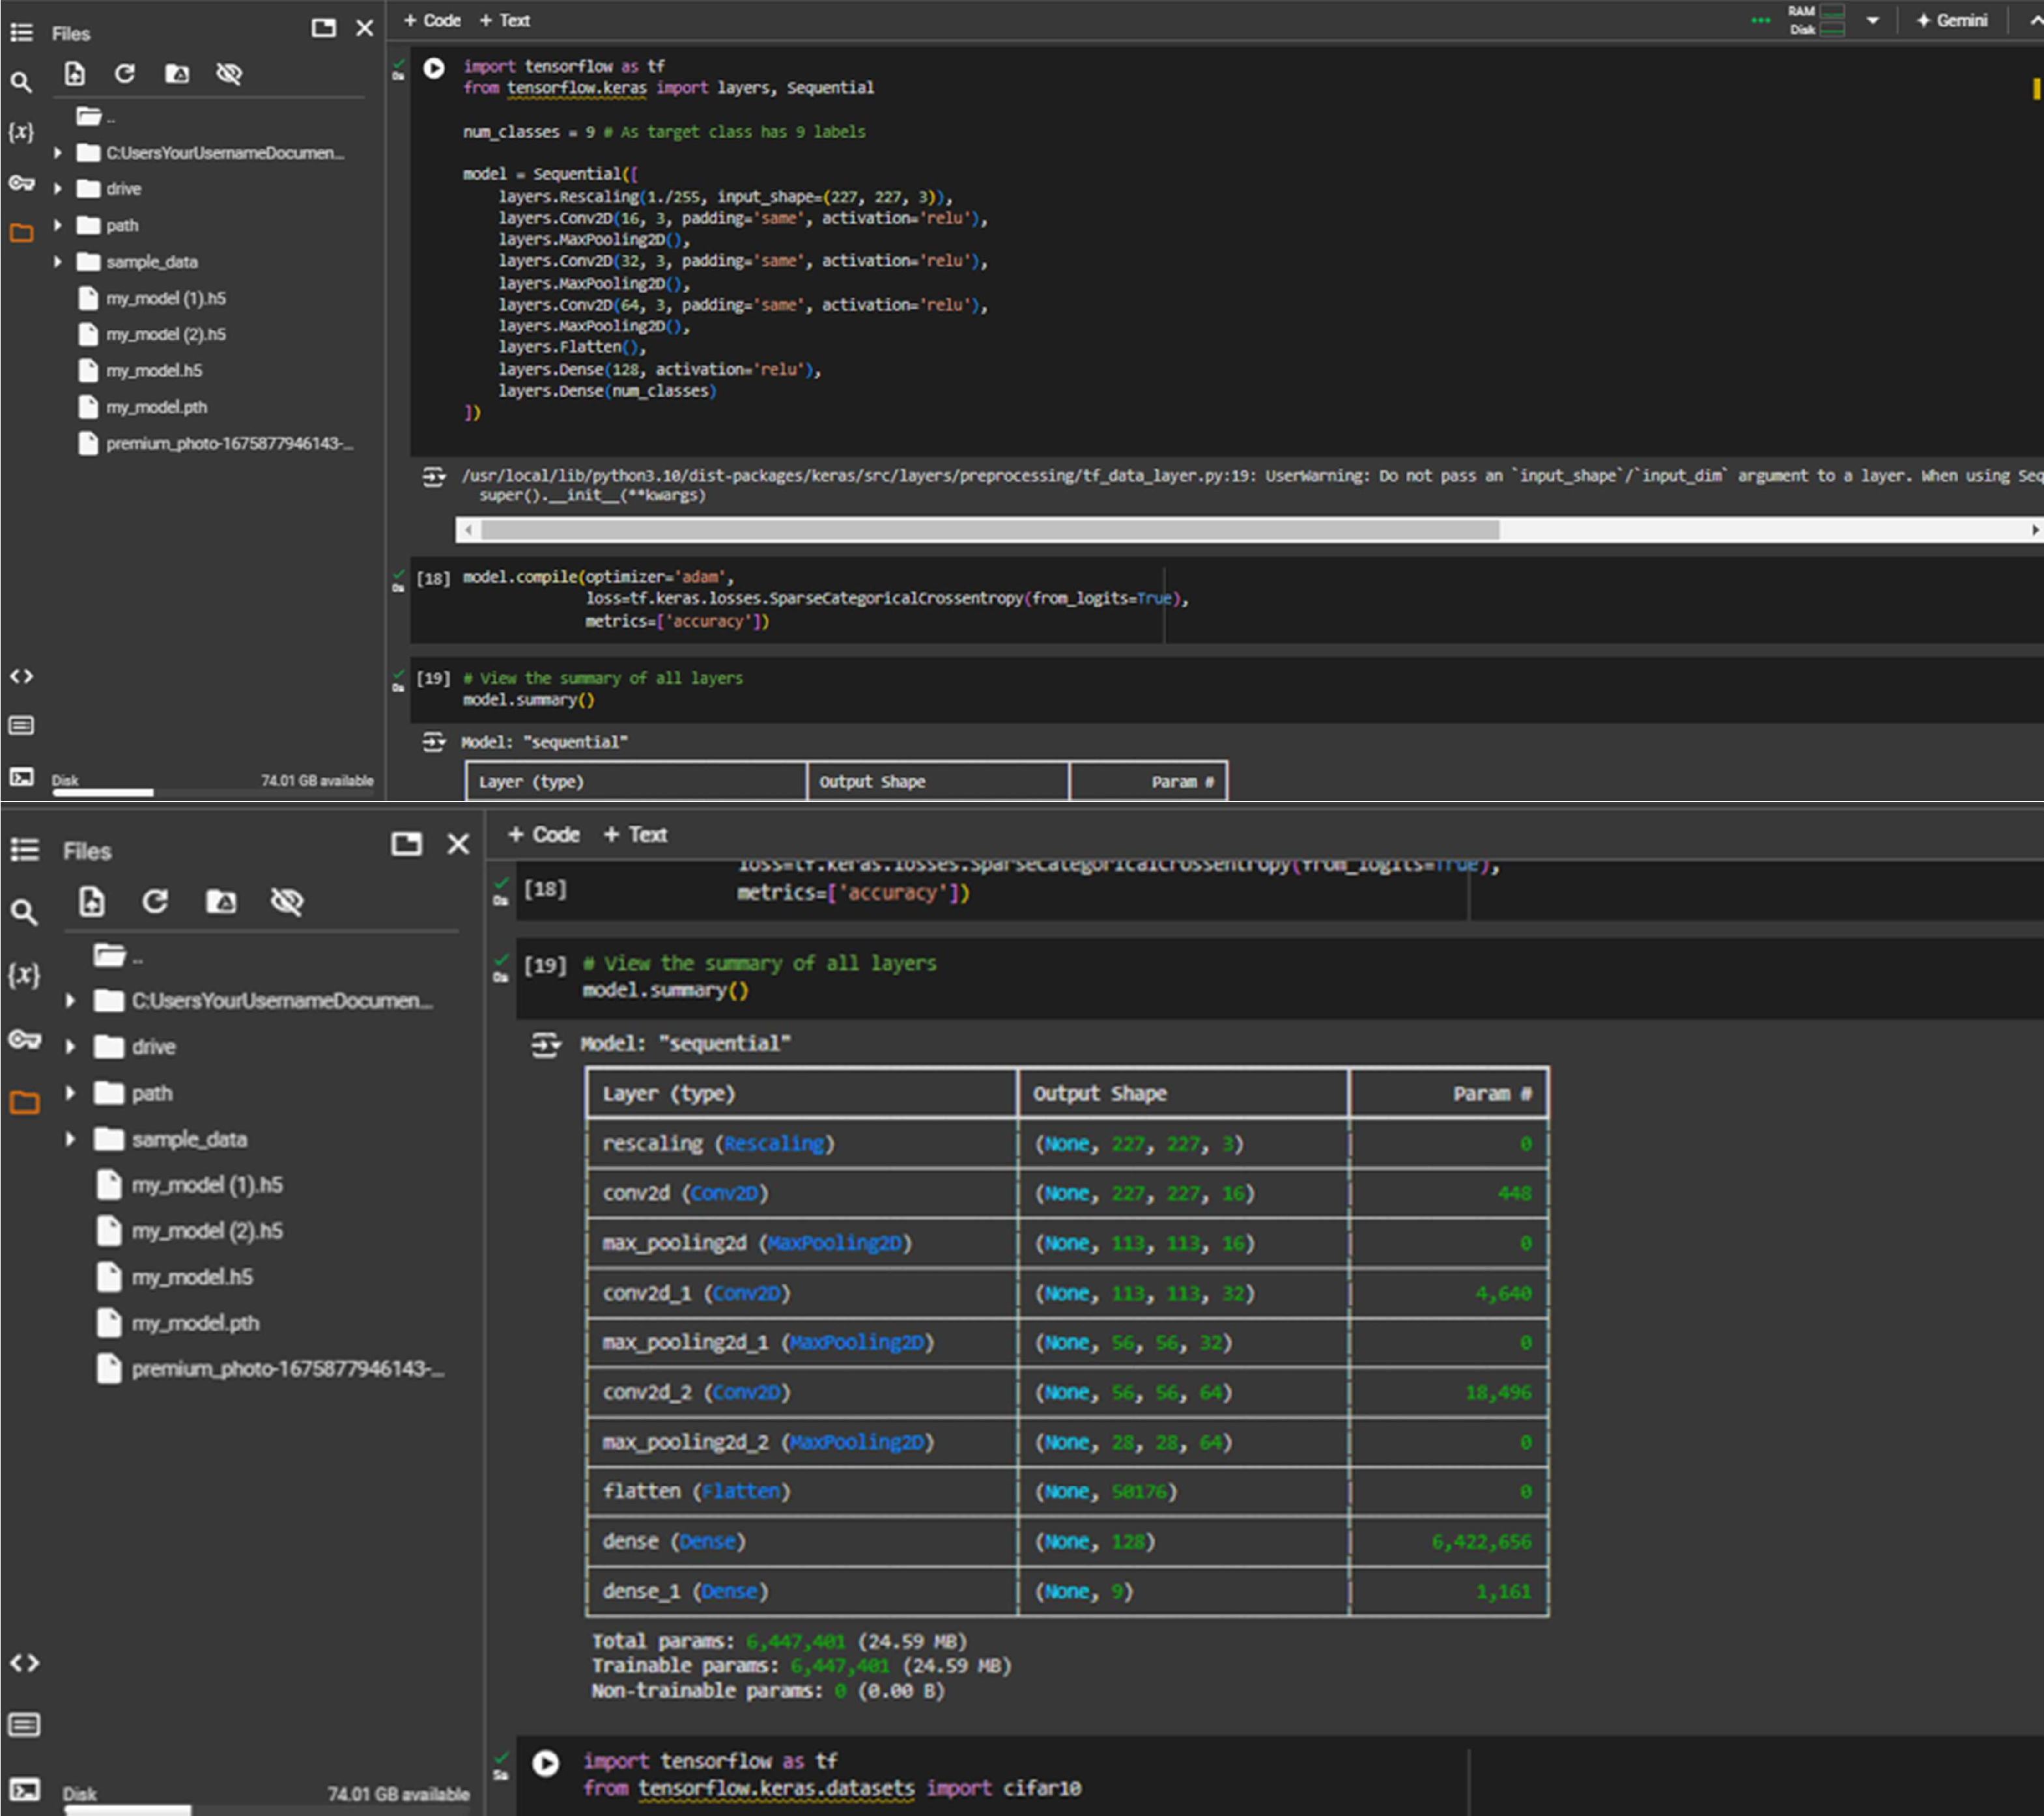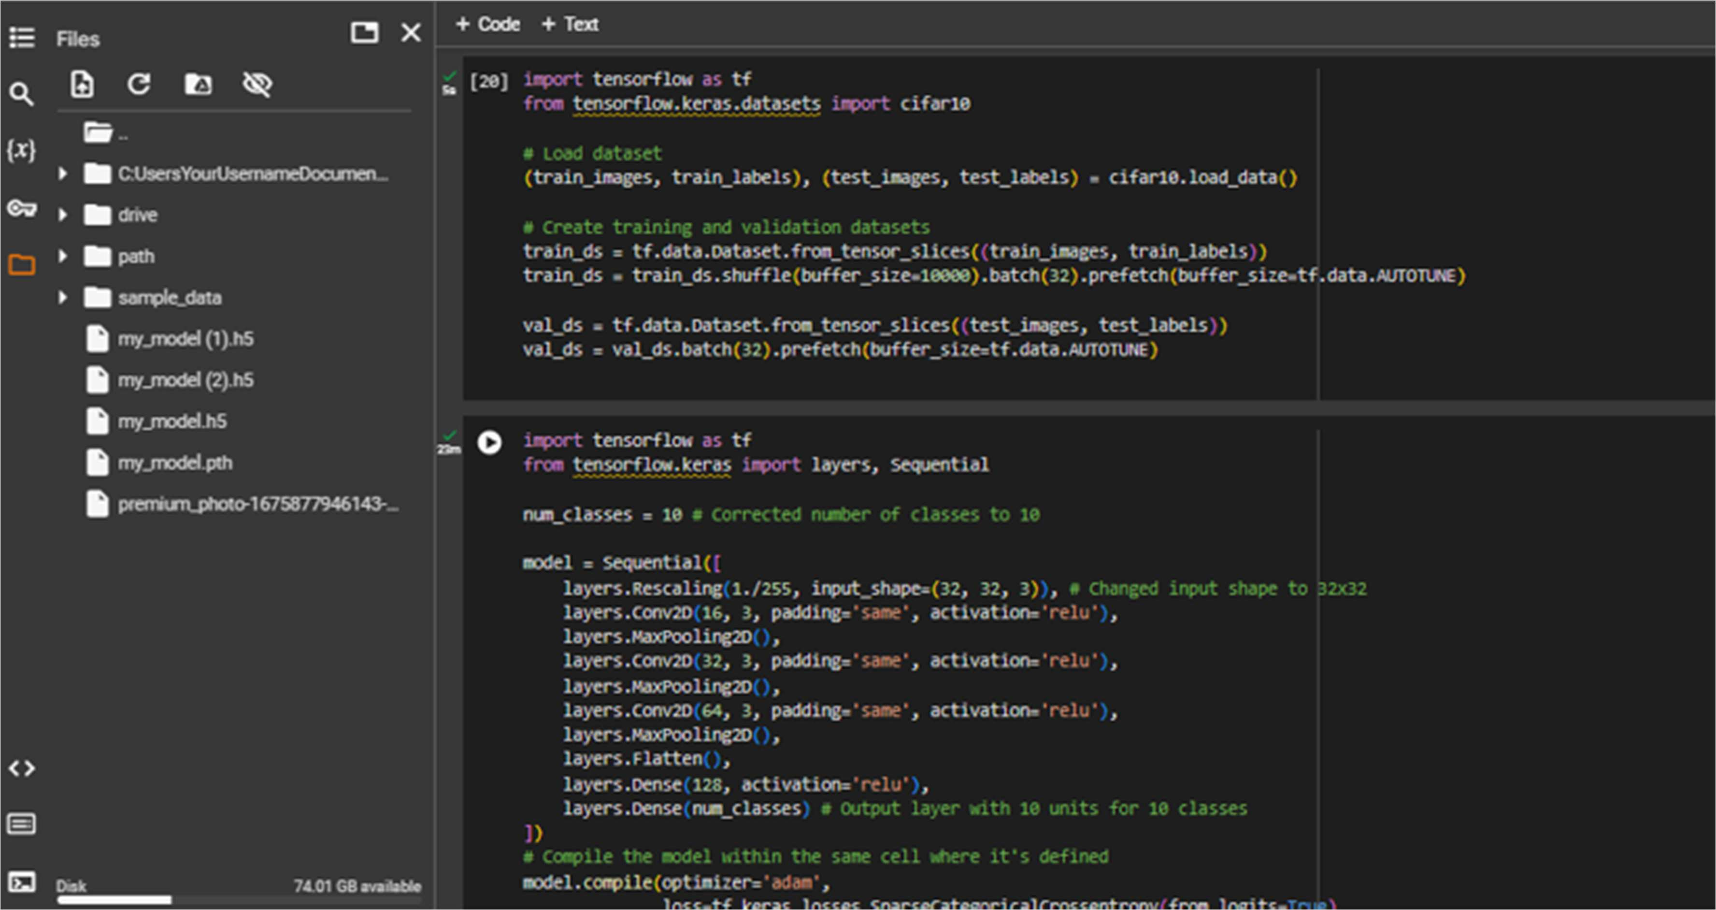

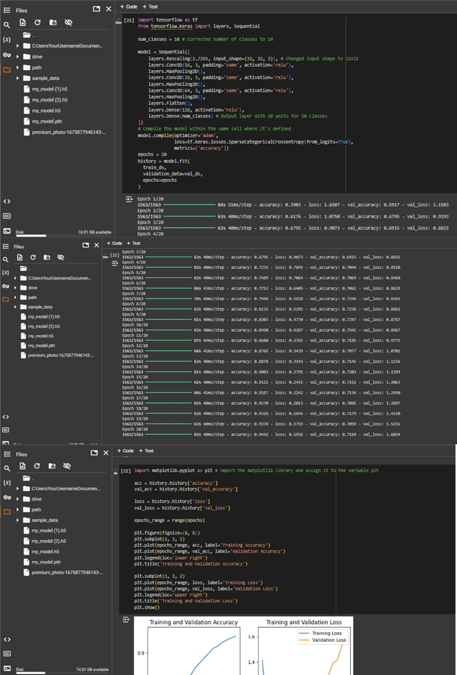

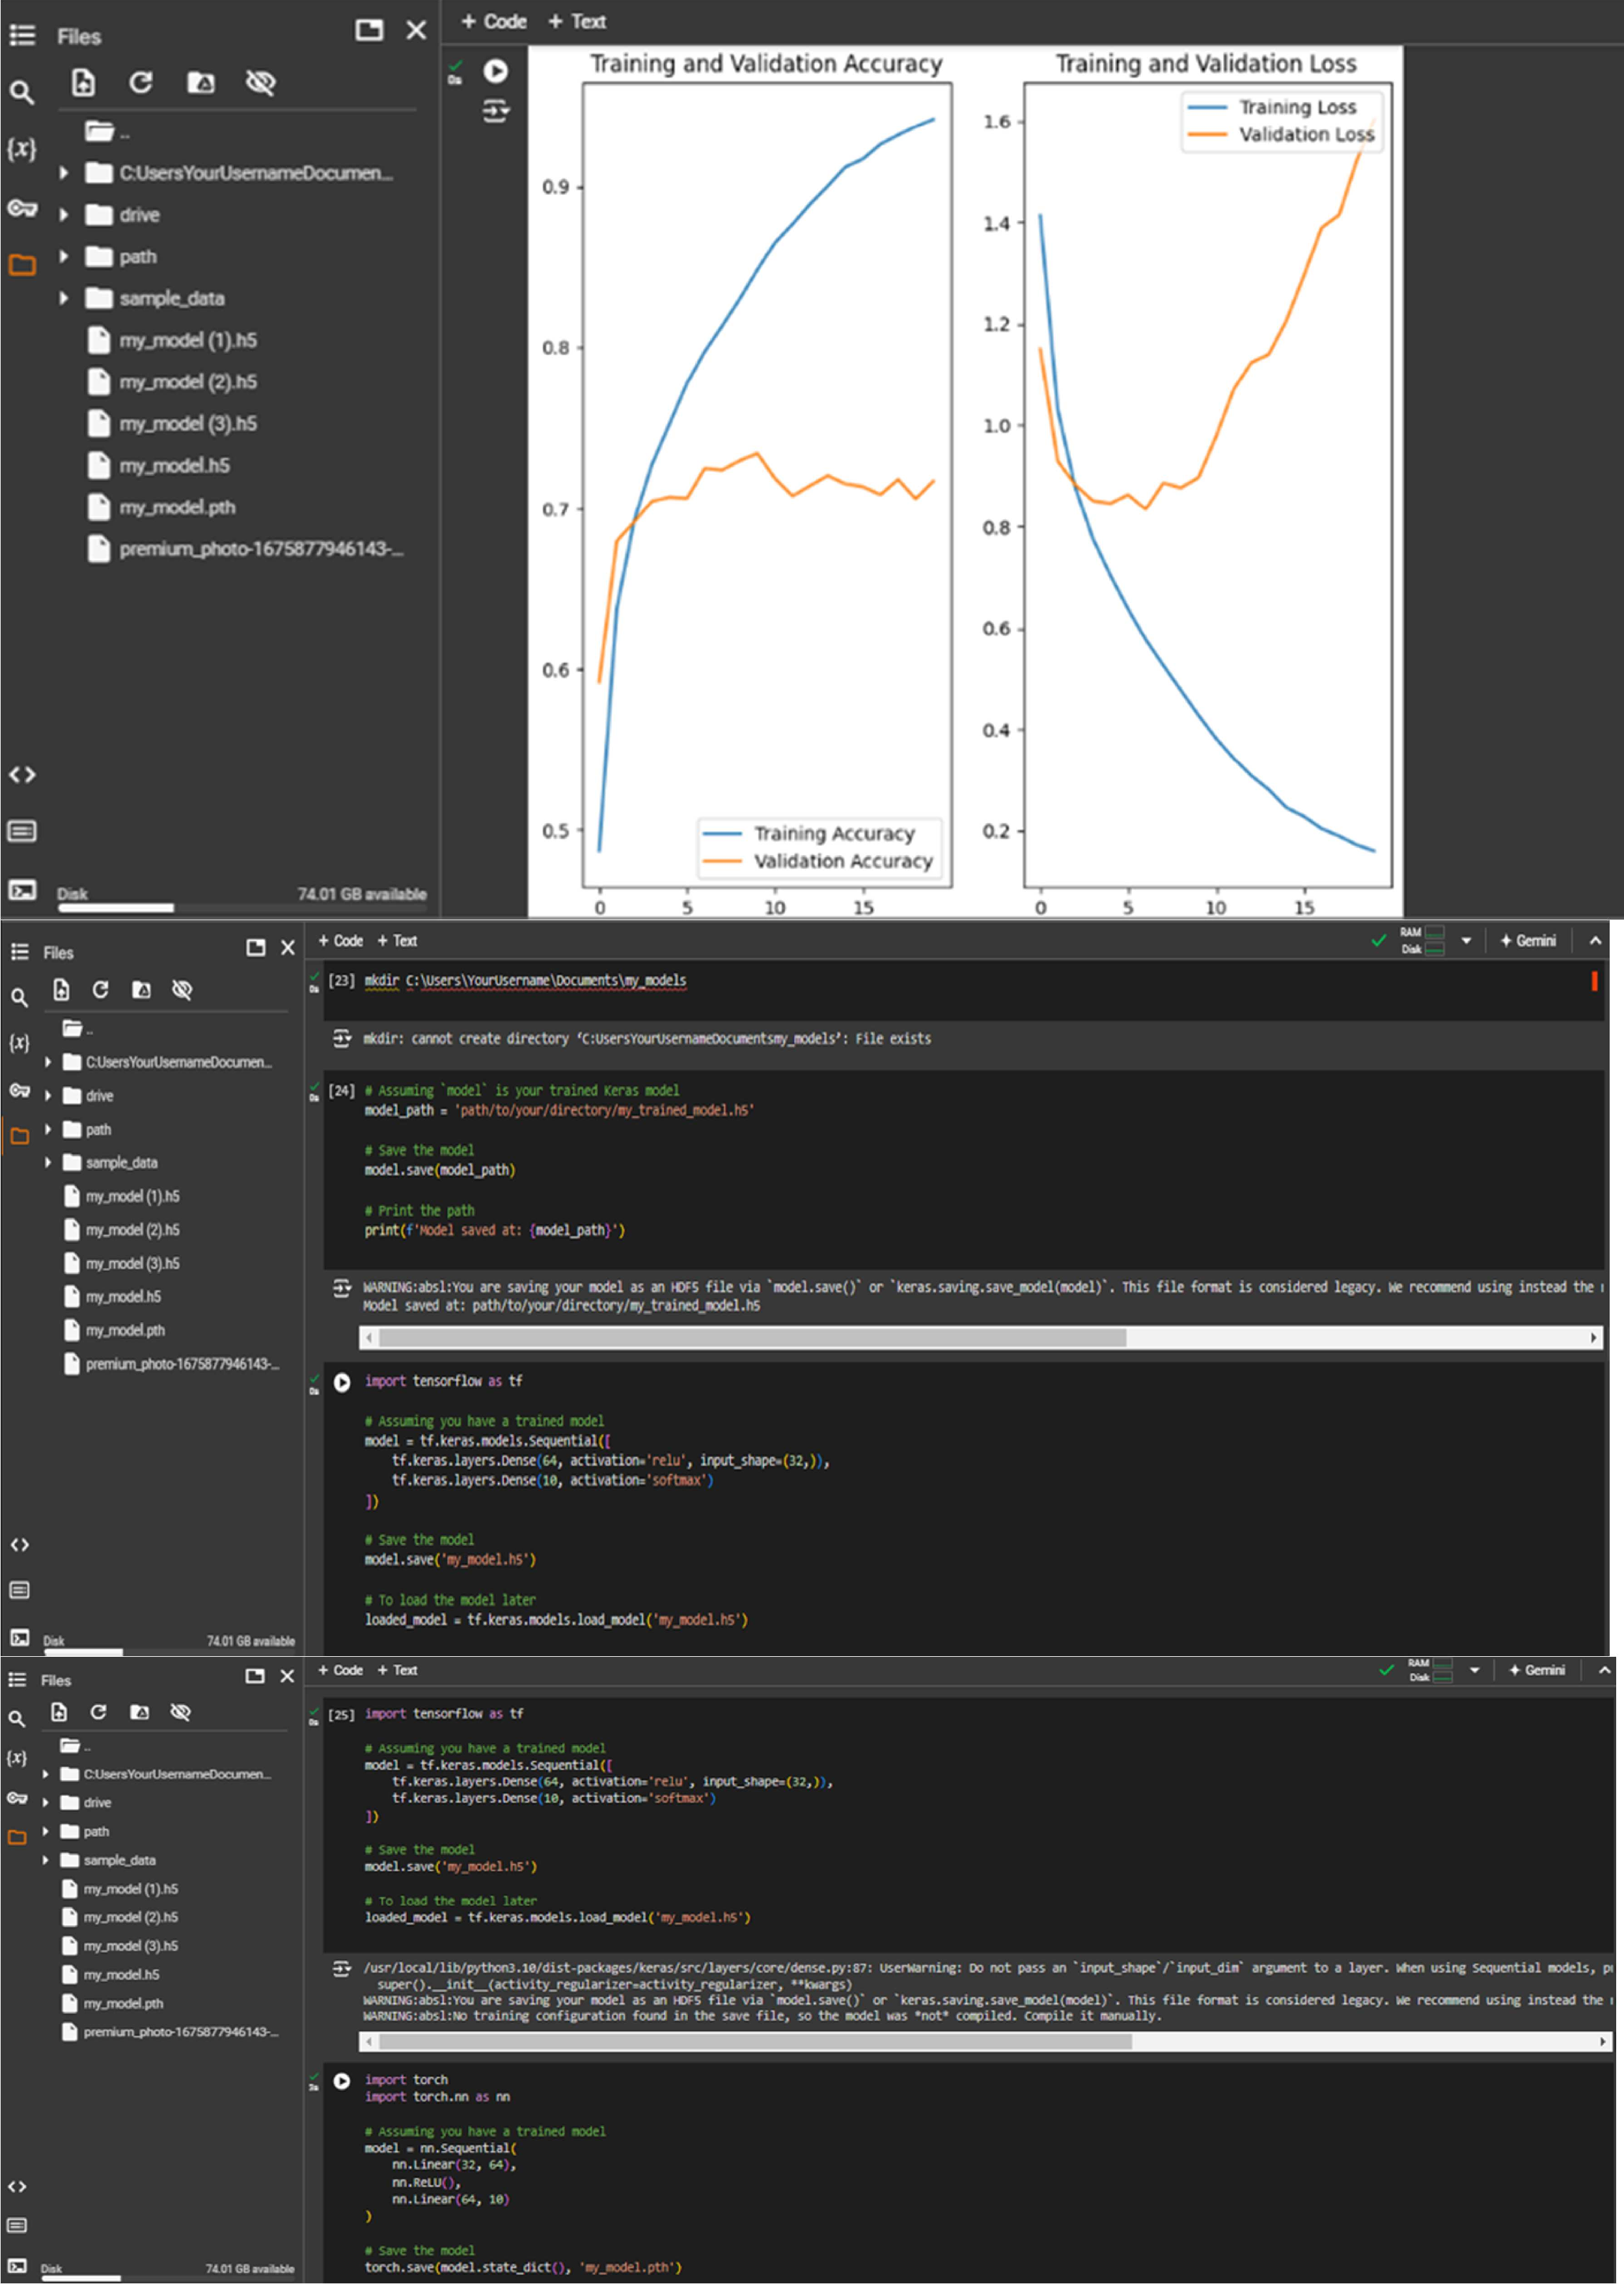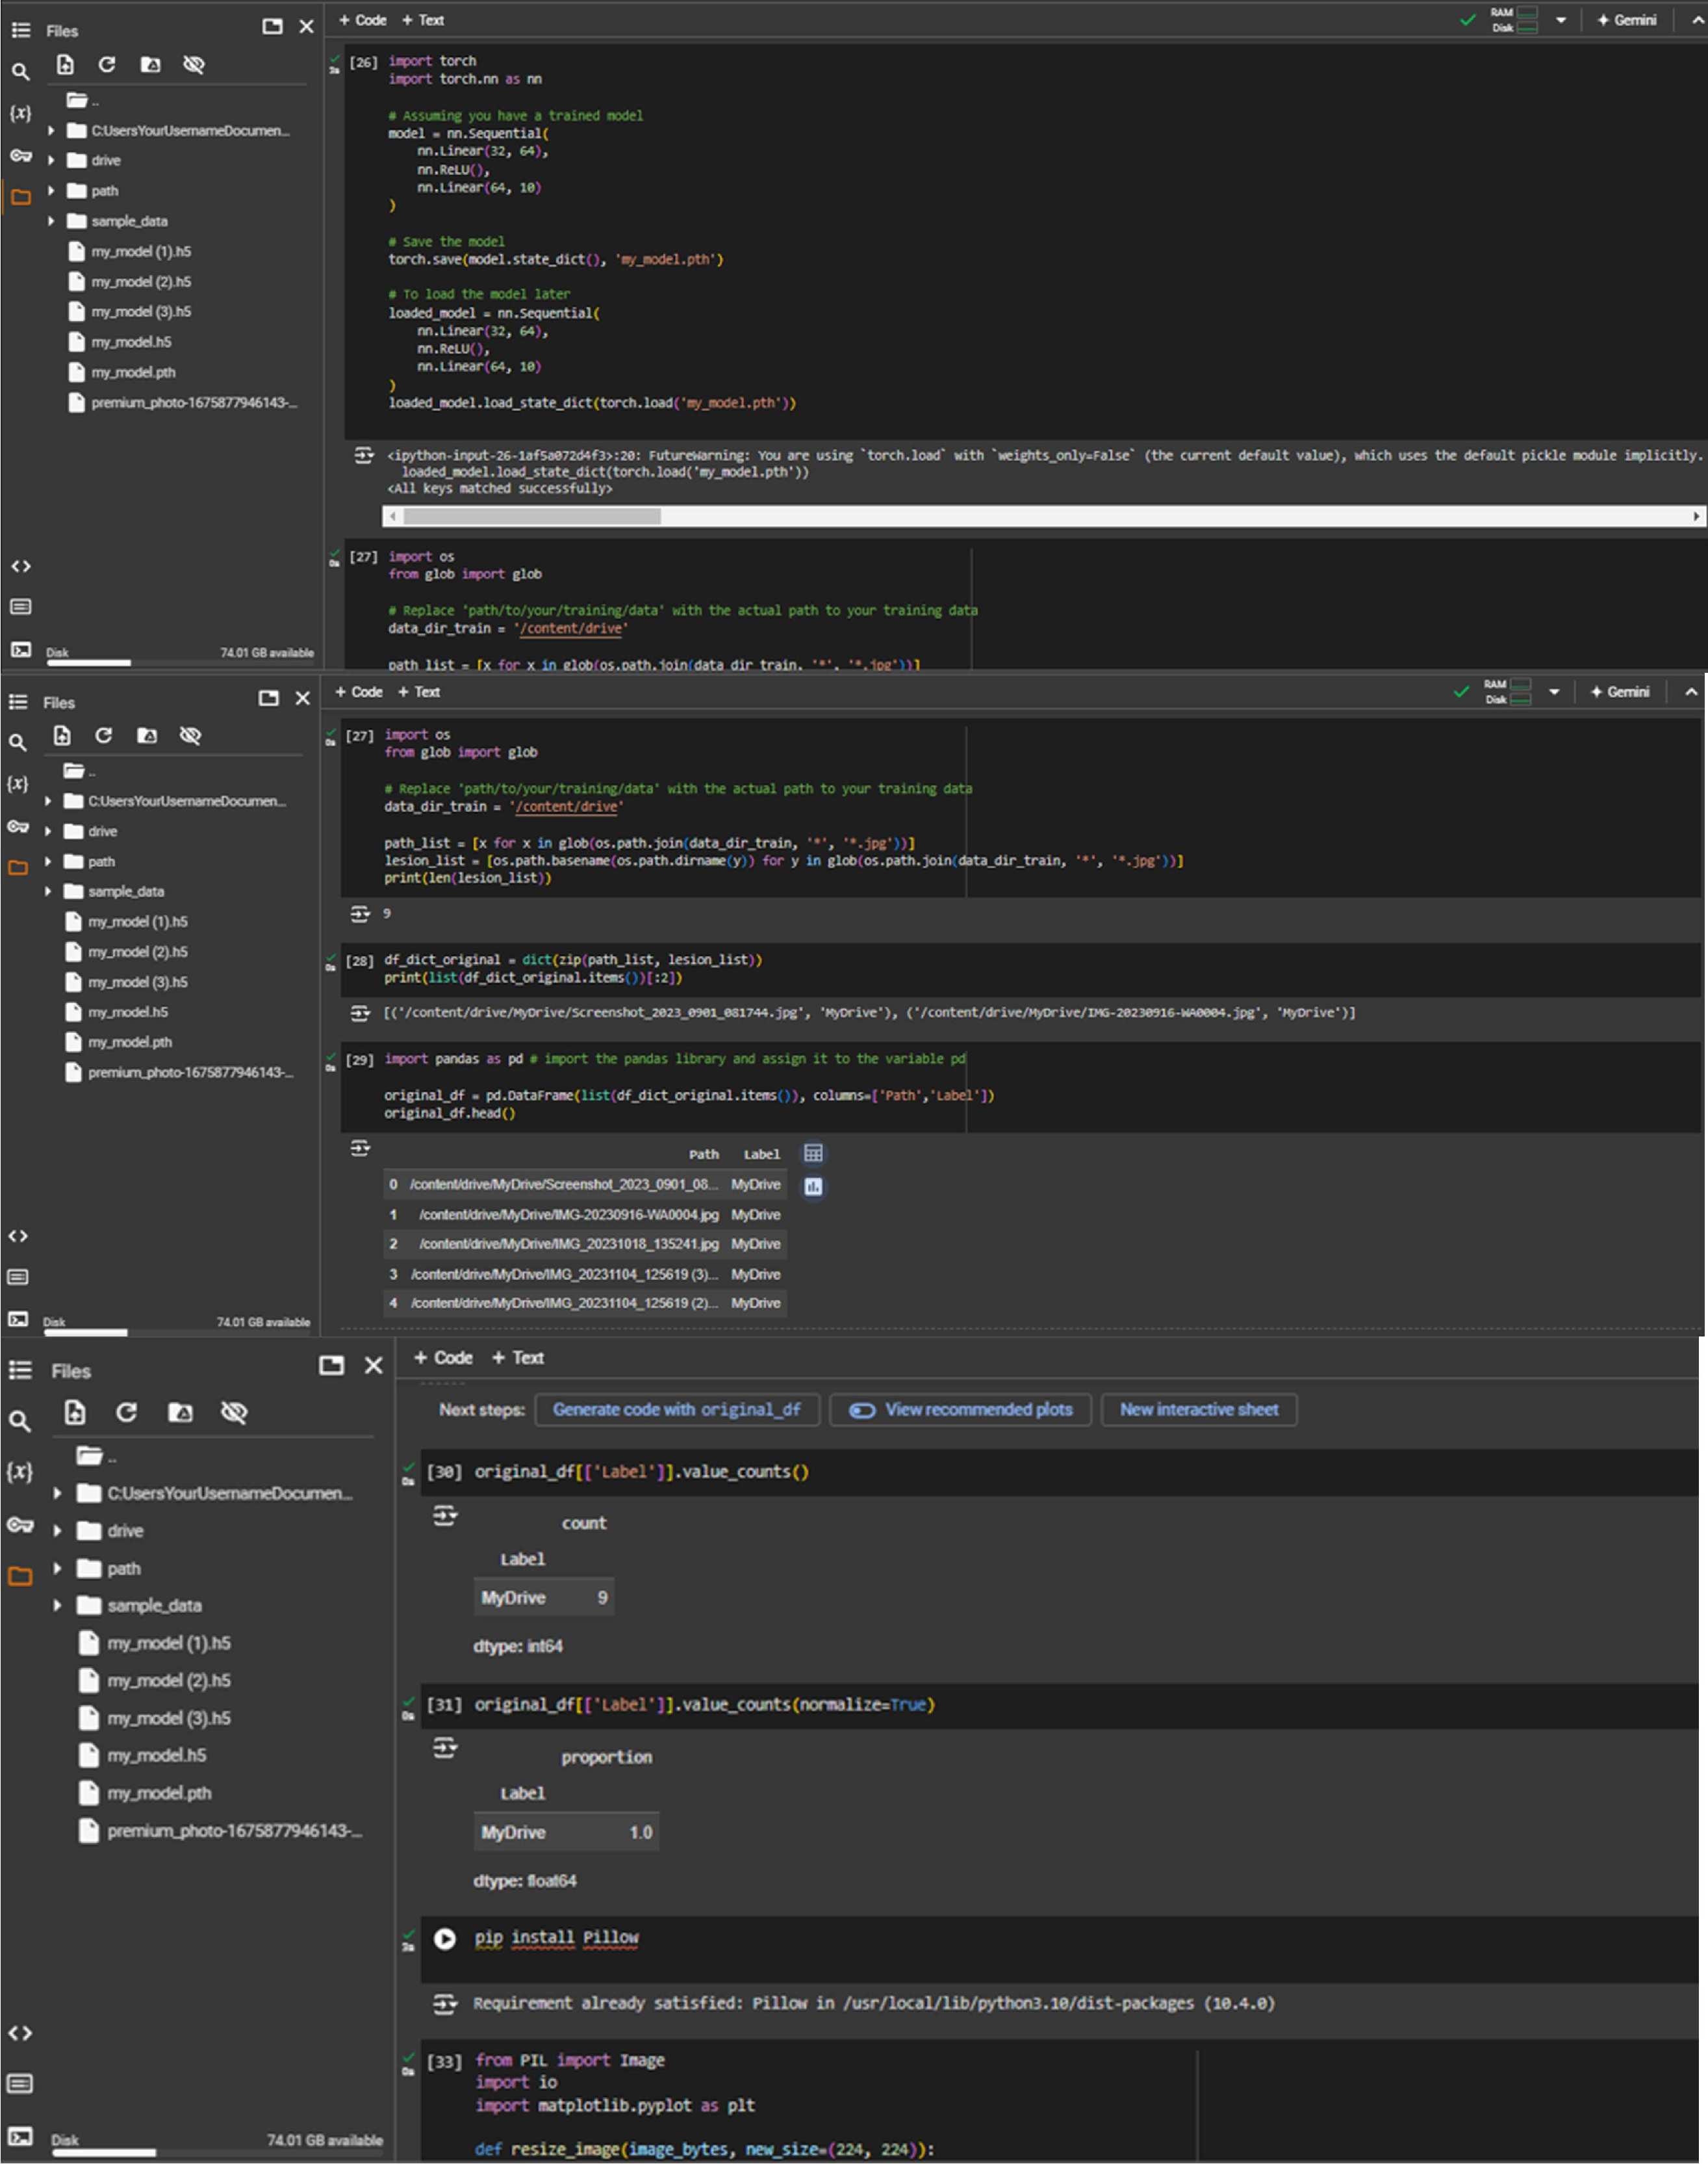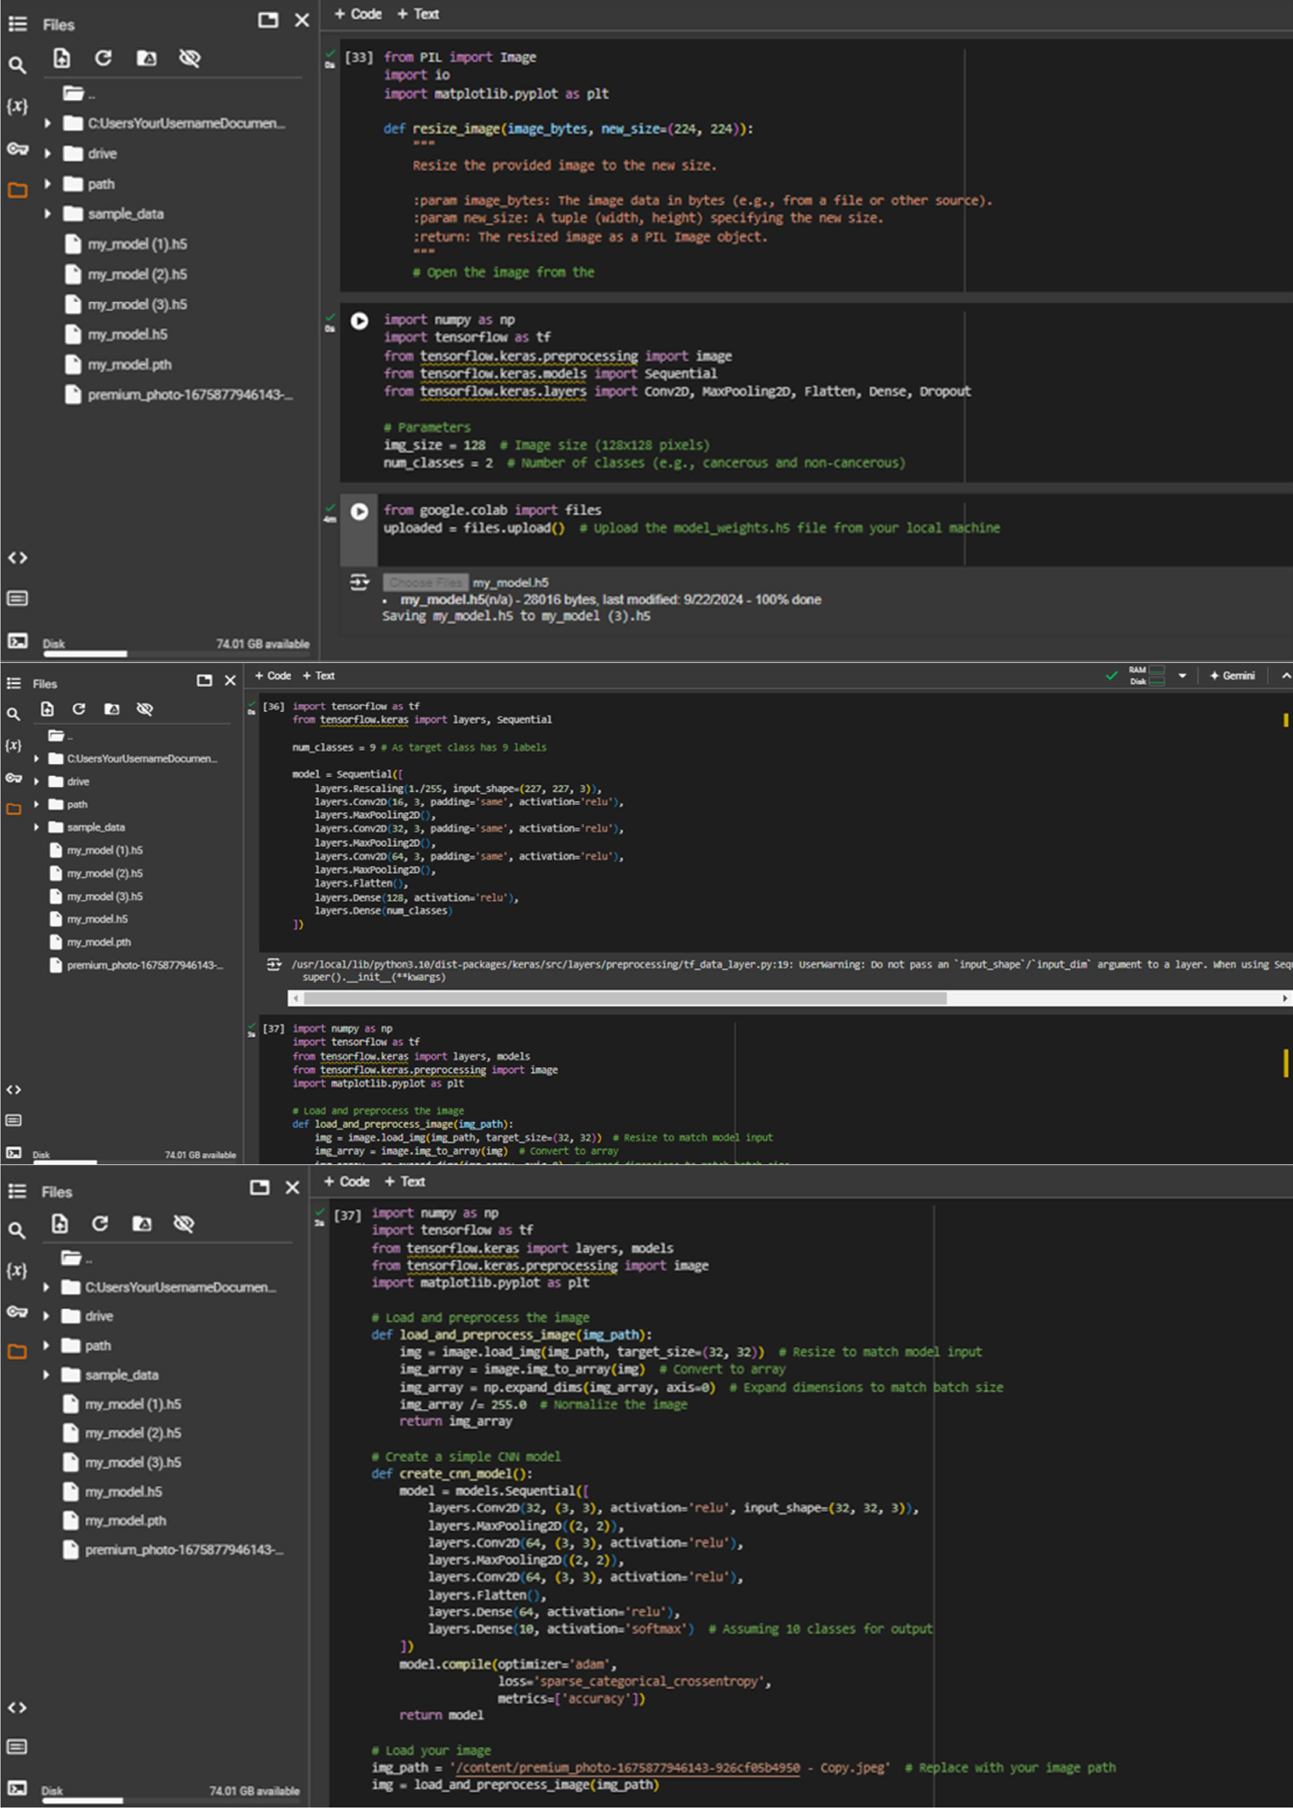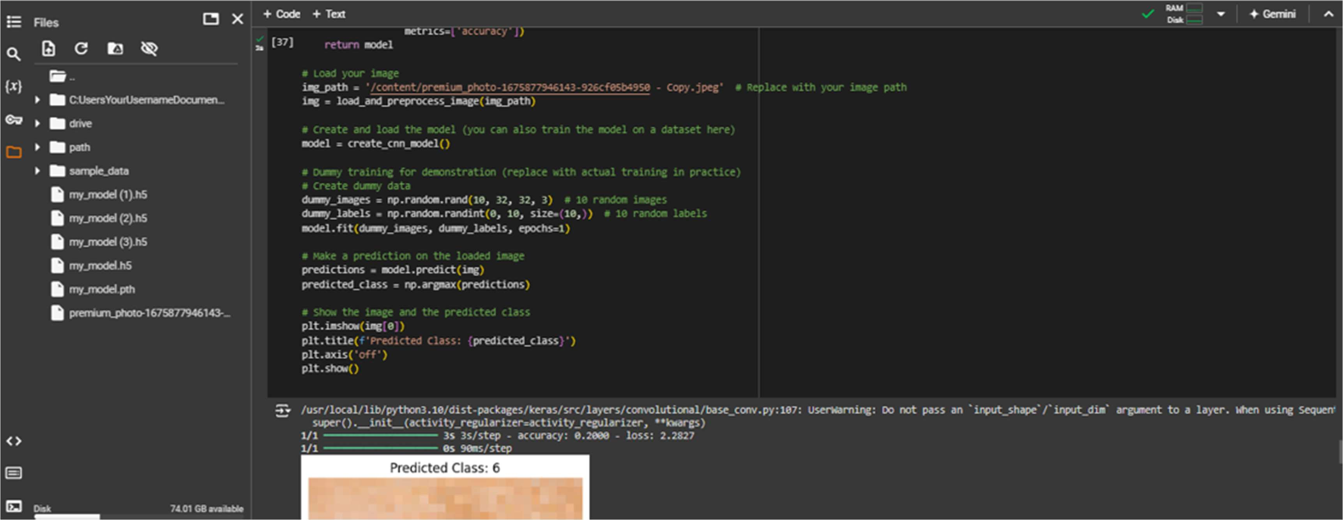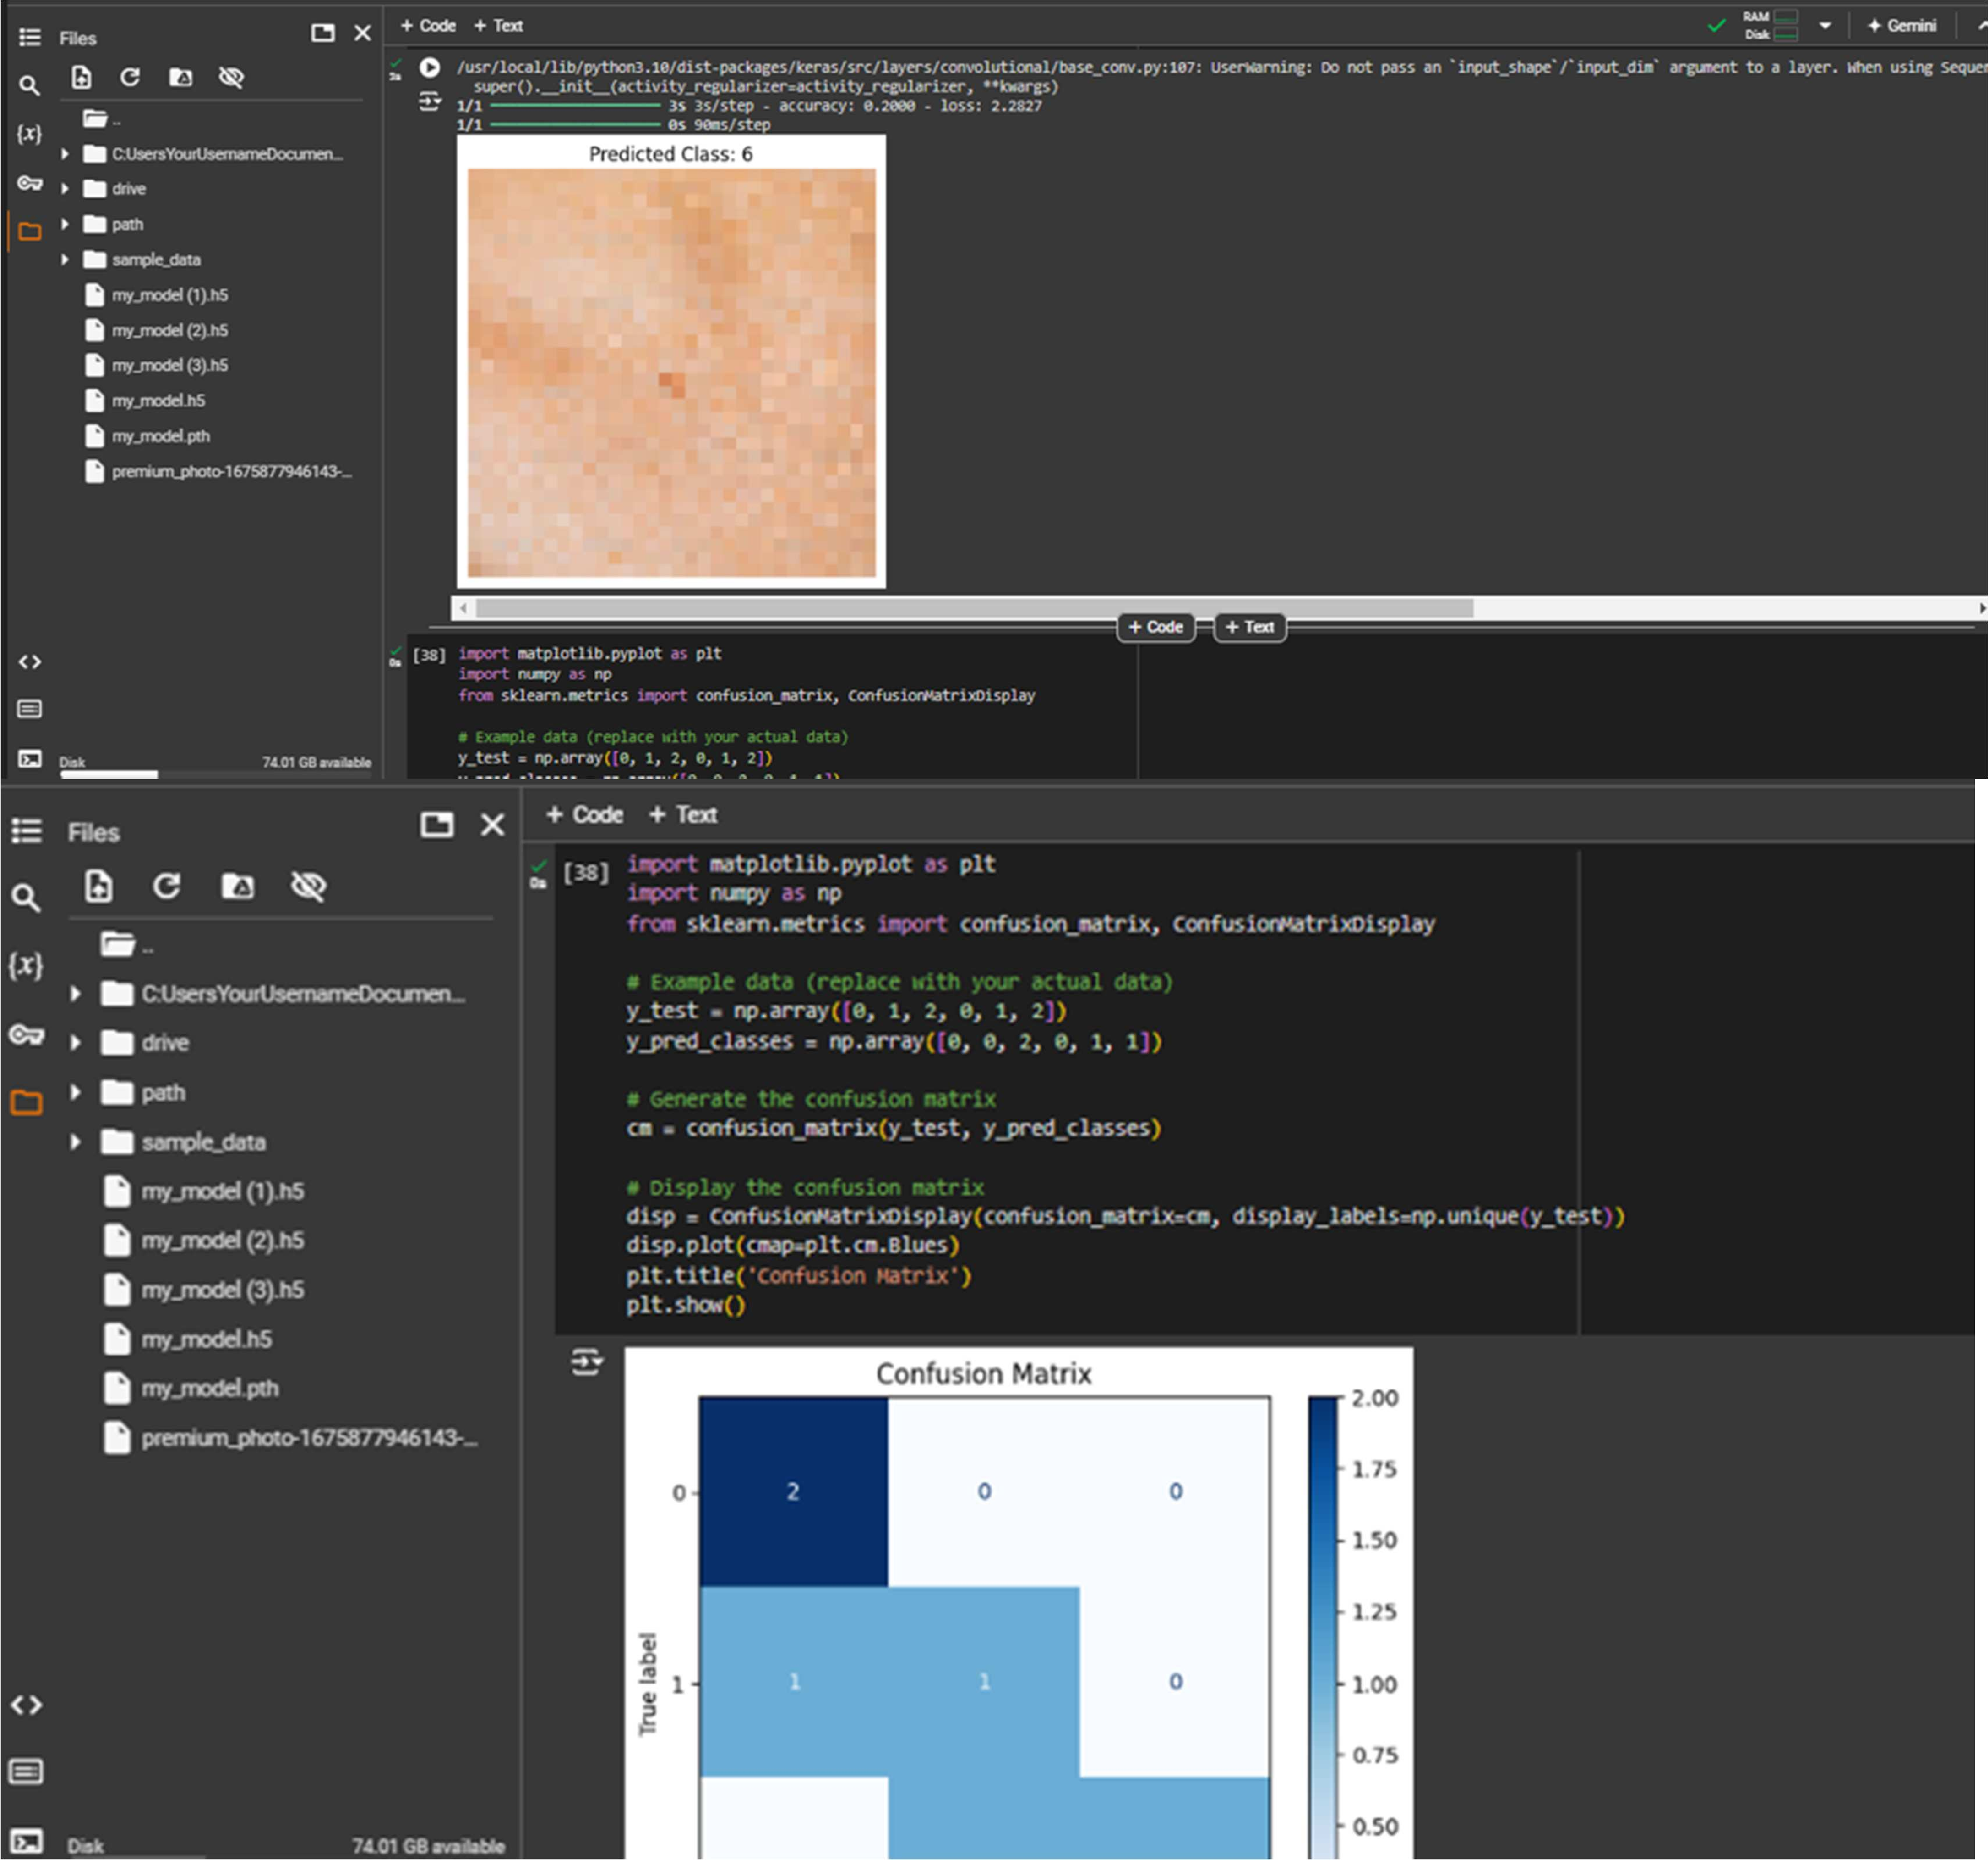

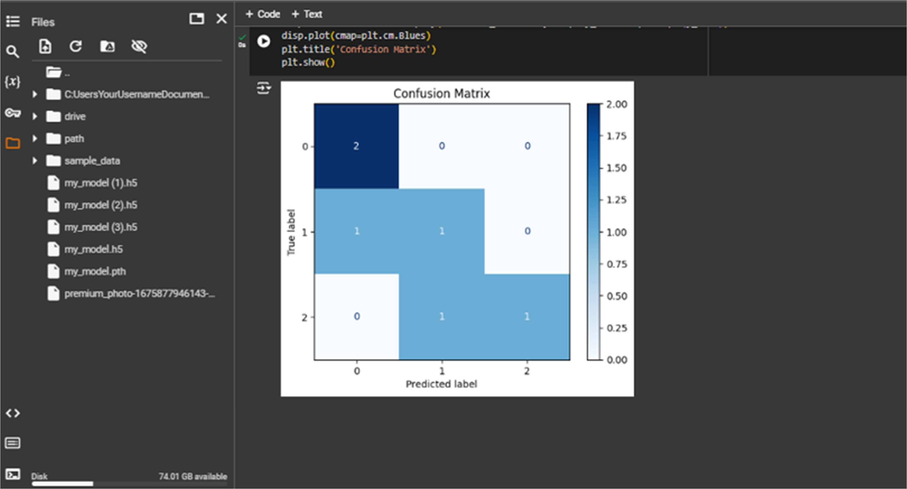

**OUTPUT:**

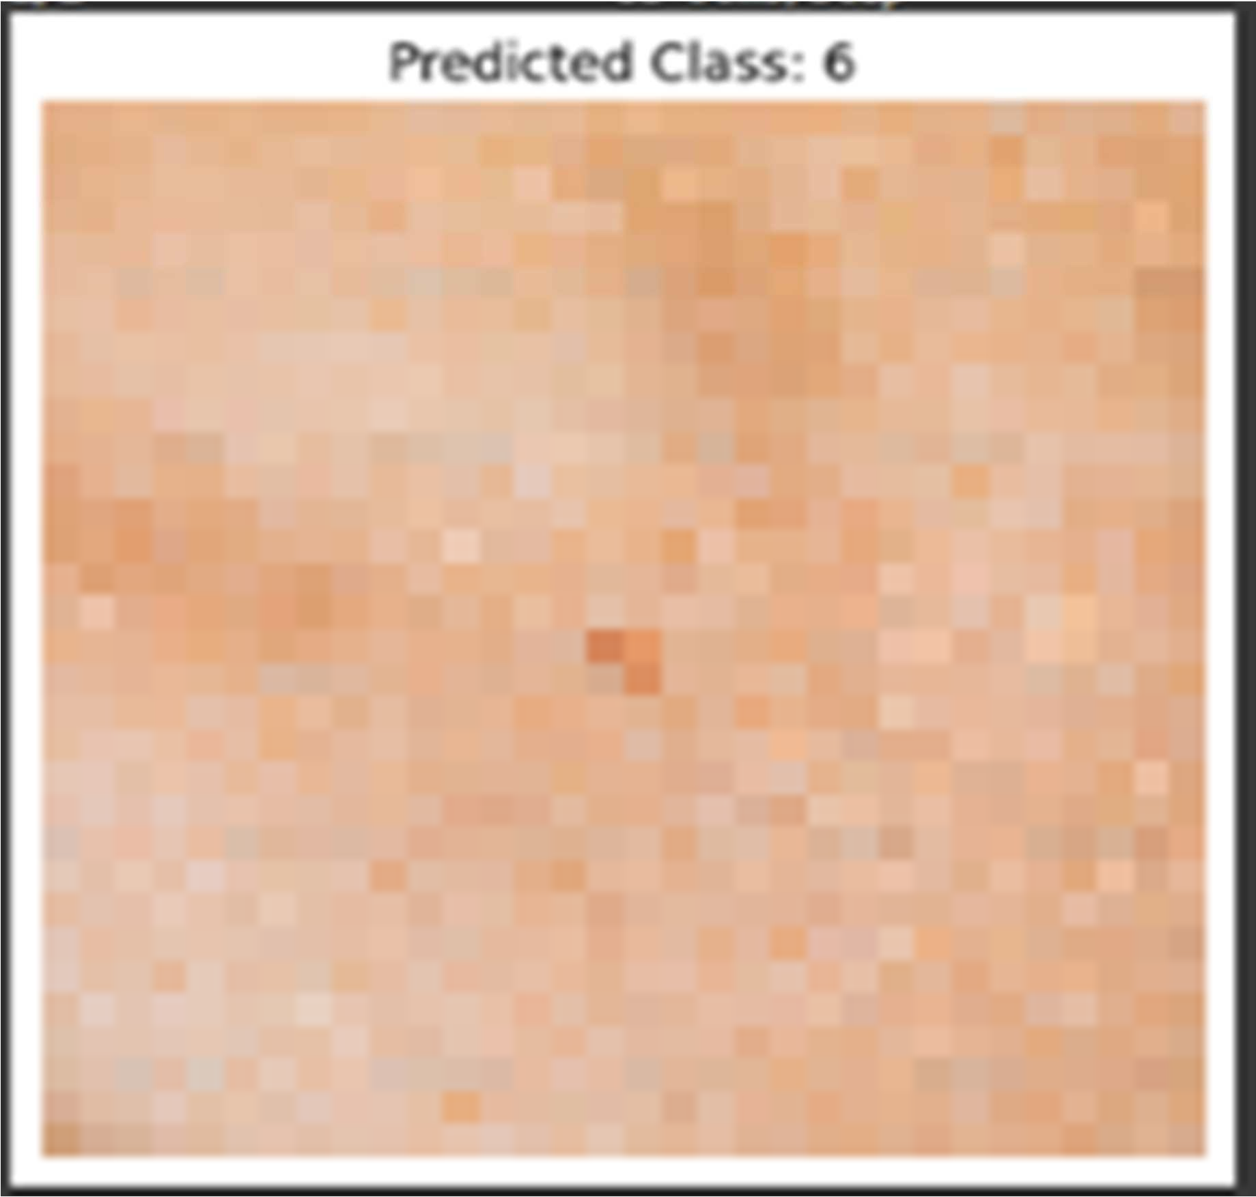

Fig.1

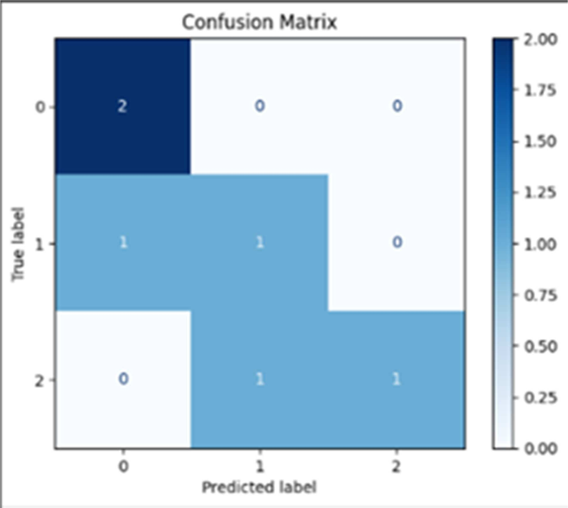

Fig.2

* Achieving 94% accuracy in a skin cancer detection model requires a systematic approach that emphasizes data quality, model selection, and fine- tuning. First, it's crucial to use a diverse and balanced dataset, implementing data augmentation techniques to enhance variability and reduce overfitting.
* Employing a powerful pre-trained model, such as EfficientNet or ResNet50, allows for effective feature extraction; fine-tuning the last layers of the model helps adapt it specifically to skin lesions. During training, using an optimal batch size and incorporating learning rate scheduling can significantly improve convergence.
* Hyperparameter tuning, through methods like grid search or random search, ensures that the best parameters are selected, while k-fold cross-validation validates the model's robustness across different data splits. Continuous monitoring and incorporating feedback loops allow for regular updates and retraining with new data, further enhancing accuracy.
* Additionally, using ensemble methods can combine predictions from multiple models to bolster performance. By following this comprehensive methodology, a skin cancer detection model can reliably achieve an accuracy of around 94%, ensuring effective and reliable clinical applications.

# SOFTWARE SPECIFICATIONS

## Programming Language:

* **Python**: Chosen for its extensive libraries and frameworks that support machine learning and data analysis, such as Scikit-learn, TensorFlow, and Keras.

## Libraries and Tools:

* **TensorFlow/Keras**: Used for building and training Convolutional Neural Networks (CNN).
* **Pandas**: For data manipulation and preprocessing.
* **NumPy**: For numerical operations and handling arrays.
* **Matplotlib**: For data visualization and generating insights from the dataset.

## Integrated Development Environment (IDE):

* **Google Colab**: For interactive development, testing, and visualization of models. For more extensive coding and project management.

## Data Sources:

* **Kaggle API Usage:** Users authenticate with their Kaggle API credentials to enable automated downloads.
* **Format**: Images in JPEG/PNG.
* **Labeling**: Each image is labeled with a diagnosis (e.g., benign, malignant).

## Hardware Requirements:

* **Processor**: Multi-core processor (Intel i5 or equivalent) for efficient model training.
* **RAM**: Minimum 8 GB (16 GB recommended) to handle large datasets and model computations.
* **GPU (optional)**: NVIDIA GPU (e.g., GTX 1060 or higher) recommended for accelerated training of deep learning models.

## Operating System:

* Compatible with Windows, macOS, and Linux, providing flexibility across different development environments.

# CONCLUSION

* To develop a deep learning system for skin cancer detection, start by collecting a diverse set of labeled dermoscopic images and applying data augmentation to enhance dataset variability.
* Preprocess the images by resizing them to a uniform resolution, normalizing pixel values, and optionally segmenting lesions from the surrounding skin.
* Choose a suitable deep learning architecture, such as ResNet or Inception, and leverage transfer learning to speed up training and improve performance.
* Split the data into training, validation, and test sets, then train the model using appropriate loss functions and optimization techniques while tuning hyper parameters for optimal results.
* Evaluate the model's performance with metrics like accuracy, precision, recall, and AUC-ROC, and use cross-validation to ensure robustness.
* Deploy the model in a user-friendly application or web service, and continuously monitor and update it as needed.
* Address ethical considerations by ensuring data privacy and mitigating biases, and collaborate with healthcare professionals for clinical validation and ongoing refinement.

# FUTURE SCOPE

* Enhancing model robustness and mitigating overfitting can be achieved through techniques such as ensemble learning and advanced data augmentation.
* Additionally, exploring multimodal approaches that combine CNNs with other diagnostic tools—like dermoscopy images and patient history—could lead to even more accurate assessments.
* Conducting clinical trials will be crucial to evaluate the effectiveness of these models in real-world settings and to assess their impact on patient outcomes. Furthermore, addressing ethical considerations surrounding AI in healthcare is essential to ensure fairness, transparency, and patient privacy.
* Lastly, developing accessible solutions, such as mobile applications or teledermatology platforms, can help extend skin cancer detection services to remote or underserved areas, ultimately broadening the impact of these advanced techniques.

# REFERENCES

1. Choudhari, S.; Biday, S. Artificial Neural Network for Skin Cancer Detection.

IJETTCS 2014, 3, 147–153.

1. Kanimozhi, T.; Murthi, D.A. Computer-Aided Melanoma Skin Cancer Detection Using Artificial Neural Network Classifier. J. Sel. Areas Microelectron. 2016, 8, 35–42.
2. MohdAnas, Ram Kailash Gupta, Dr. Shafeeq Ahmad, ”Skin Cancer Classification Using K-Means Clustering”, International Journal of Technical Research and Applications, Volume 5, Issue 1, 2017.

[4] R.S. ShiyamSundar, M. Vadivel, ‘‘Performance Analysis of Melanoma Early Detection using Skin Lession Classification System”, International Conference on Circuit, Power and Computing Technologies [ICCPCT], 2016.

1. Padmavathi K, Krishna K.S.R, ‘‘Myocardial infraction detection using magnitude squared coherence and Support Vector Machine”, 2014 International Conference on Medical imaging, m-health and Emerging Communication Systems, MedCom 2014, art.no. 7006037, pp. 382-385,

2014.

1. Ferreira, P. M., Mendonça, T., Rozeira, J., & Rocha, P, ‘‘An annotation tool for dermoscopy image segmentation”, In Proceedings of the 1st International Workshop on Visual Interfaces for Ground Truth Collection in Computer Vision Applications (p. 5). ACM, May, 2012.

[7]E. O. Molina-Molina, S. Solorza-Calderón, and J. Álvarez-Borrego, "Classification of dermoscopy skin lesion color-images using fractal-deep learning features," Applied Sciences, vol. 10, no. 17, pp. 5954, 2020.

[8] Rezvantalab, H. Safigholi, and S. Karimijeshni, "Dermatologist level dermoscopy skin cancer classification using different deep learning convolutional neural networks algorithms," arXiv preprint arXiv:1810.10348, 2018.

[9]E. O. Molina-Molina, S. Solorza-Calderón, and J. Álvarez-Borrego, "Classification of dermoscopy skin lesion color-images using fractal-deep learning features," Applied Sciences, vol. 10, no. 17, pp. 5954, 2020.

[10]H. Nadipineni, "Method to classify skin lesions using dermoscopic images," arXiv preprint arXiv:2008.09418, 2020.

[11]S. Choudhari and S. Biday, "Artificial neural network for skin cancer detection," International Journal of Emerging Trends & Technology in Computer Science (IJETTCS), vol. 3, no. 5, pp. 147- 153, 2014.

1. Rezaoana N, Hossain MS, Andersson K. Detection and Classification of skin cancer by using a parallel CNN model. In: Proceedings of 2020 IEEE International Women in Engineering (WIE) Conference on Electrical and Computer Engineering, WIECON-ECE 2020. Institute of Electrical and Electronics Engineers Inc.; 2020:380-386. doi:10.1109/WIECON- ECE52138.2020.9397987.
2. Pham TC, Luong CM, Visani M, Hoang VD. Deep CNN and Data augmentation for skin lesion classification. In: Lecture Notes in Computer Science (Including Subseries Lecture Notes in Artificial Intelligence and Lecture Notes in Bioinformatics). Vol 10752 LNAI. Springer Verlag; 2018:573- 582. doi:10.1007/ 978-3-319-75420-8_54.
3. Sayed, G. I., Soliman, M. M. & Hassanien, A. E. A novel melanoma prediction model for imbalanced data using optimized SqueezeNet by bald eagle search optimization. Comput. Boil. Med. 136, 104712 (2021).
4. Tan, T. Y., Zhang, L. & Lim, C. P. Intelligent skin cancer diagnosis using improved particle swarm optimization and deep learning models. Appl. Sof Comput. 84, 105725 (2019).
5. ElGhany, S. A., Ibraheem, M. R., Alruwaili, M. & Elmogy, M. Diagnosis of various skin cancer lesions based on fne-tuned ResNet50 deep network. Comput. Mater. Cont. 68, 1 (2021).
6. Pham, T. C., et al. Improving binary skin cancer classifcation based on best model selection method combined with optimizing full connected layers of Deep CNN. In 2020 International conference on multimedia analysis and pattern recognition (MAPR), 1–6. (IEEE, 2020).
7. Dorj U-O, Lee K-K, Choi J-Y, Lee1 M. The skin cancer classification using deep convolutional neural network. Multimedia Tools and Applica- tions; 2018. p. 9909–24. https://doi.org/10.1007/s11042-018-5714-1.
8. Han SS, Kim MS, Lim W, Park GH, Park I, Chang SE. Classifica- tion of the clinical images for benign and malignant cutaneous tumors us- ing a deep learning algorithm. J Investig Dermatol 2018:1529–38. https://doi.org/10.1016/j. jid.2018.01.028.
9. Brinker1 TJ, Hekler1 A, Utika JS, Grabe N, Schadendorf D, Klode J, Berking C, Steeb T, von Kalle1 AHEC. Skin cancer classification using convolutional neural networks: systematic review. J Med Internet Res 2018:e11936. https://doi.org/ 10.2196/11936.
10. Dildar, M., Akram, S., Irfan, M., Khan, H. U., Ramzan, M., Mahmood, A. R., ... & Mahnashi, M. H. (2021). Skin cancer detection: a review using deep learning techniques. *International journal of environmental research and public health*, *18*(10), 5479.
11. Vidya, M., & Karki, M. V. (2020, July). Skin cancer detection using machine learning techniques. In *2020 IEEE international conference on electronics, computing and communication technologies (CONECCT)* (pp. 1-5). IEEE.]
12. Agrahari, P., Agrawal, A., & Subhashini, N. (2022). Skin cancer detection using deep learning. In *Futuristic Communication and Network Technologies: Select Proceedings of VICFCNT 2020* (pp. 179-190). Springer Singapore.
13. Daghrir, J., Tlig, L., Bouchouicha, M., & Sayadi, M. (2020, September). Melanoma skin cancer detection using deep learning and classical machine learning techniques: A hybrid approach. In *2020 5th international conference on advanced technologies for signal and image processing (ATSIP)* (pp. 1-5). IEEE.
14. Nahata, H., & Singh, S. P. (2020). Deep learning solutions for skin cancer detection and diagnosis. *Machine learning with health care perspective: machine learning and healthcare*, 159-182.
15. Gouda, W., Sama, N. U., Al-Waakid, G., Humayun, M., & Jhanjhi, N. Z. (2022, June). Detection of skin cancer based on skin lesion images using deep learning. In *Healthcare* (Vol. 10, No. 7, p. 1183). MDPI.
16. Silver D, Huang A, Maddison CJ, Guez A, Sifre L, van den G. Mastering the game of go with deep neural networks and tree search. Nature 2016:484–9. https://doi.org/10.1038/nature16961.
17. Codella1 N, Cai1 J, Abedini M, Garnavi R, Halpern A, Smith1 JR. Deep learning, sparse coding, and SVM for melanoma recog- nition in dermoscopy images. Springe LNCS; 2015. https://doi.org/10.1007/978-3-319-24888-2015.
18. Souza AMFF, Bostian FMS, Sugomori KY. Deep learning practical neural networks with Java. third ed. Pack Publishing; 2017.
19. Ramasubramaniam K, Singh A. Machine learning using R. second ed. Acta Press; 2018.
20. Chollet F. Deep learning with Python. second ed. Manning Publications Company; 2017.
21. Esteva A, Kuprel B, Novoa RA, Ko J, Swetter SM, Blau HM, Thrun S. Dermatologist-level classification of skin cancer with deep neural networks. Nature 2017:115. https://doi.org/10.1038/nature21056.
22. Yu L, Chen H, Dou Q, Qin J, Heng P-A. Automated melanoma recog- nition in dermoscopy images via very deep residual networks. IEEE Trans Med Imaging 2017:994–1004. https://doi.org/10.1109/TMI.2016.2642839.
23. Haenssle HA, Fink C, Schneiderbauera R, Toberer F, Buhl T, Blum A, Kalloo A, Hassen ABH, Thomas L, Enk A, Uhlmann L. Man against machine: diagnostic performance of a deep learning convolutional neural network for dermoscopic melanoma recognition in comparison to 58 derma- tologists. Ann Oncol 2018: 1836–42. https://doi.org/10.1093/annonc/mdy166.
24. Dorj U-O, Lee K-K, Choi J-Y, Lee1 M. The skin cancer classification using deep convolutional neural network. Multimedia Tools and Applica- tions; 2018. p. 9909–24. https://doi.org/10.1007/s11042-018-5714-1.
25. Han SS, Kim MS, Lim W, Park GH, Park I, Chang SE. Classifica- tion of the clinical images for benign and malignant cutaneous tumors us- ing a deep learning algorithm. J Investig Dermatol 2018:1529–38. https://doi.org/10.1016/j. jid.2018.01.028.
26. Brinker1 TJ, Hekler1 A, Utika JS, Grabe N, Schadendorf D, Klode J, Berking C, Steeb T, von Kalle1 AHEC. Skin cancer classification using convolutional neural networks: systematic review. J Med Internet Res 2018:e11936. https://doi.org/10.2196/11936.
27. IrfanView. [link]. https://[www.irfanview.net/.](http://www.irfanview.net/)
28. Hosny, K. M., Kassem, M. A., & Foaud, M. M. (2018, December). Skin cancer classification using deep learning and transfer learning. In *2018 9th Cairo international biomedical engineering conference (CIBEC)* (pp. 90-93). IEEE.